Building a simple neural network using Keras and Tensorflow - Updated
Update: The original code has been updated to use the tidymodels init_split() function, rather than using the indicies method which originally used setdiff, which now may have a conflict between base R and the tidyverse.
Thank you
A big thank you to Leon Jessen for posting his code on github.
Building a simple neural network using Keras and Tensorflow
I have forked his project on github and put his code into an R Notebook so we can run it in class.

Motivation
The following is a minimal example for building your first simple artificial neural network using Keras and TensorFlow for R.
TensorFlow for R by Rstudio lives here.

Gettings started - Install Keras and TensorFlow for R
You can install the Keras for R package from CRAN as follows:
# install.packages("keras")
TensorFlow is the default backend engine. TensorFlow and Keras can be installed as follows:
# library(keras)
# install_keras()
Naturally, we will also need Tidyverse.
# Install from CRAN
# install.packages("tidyverse")
# Or the development version from GitHub
# install.packages("devtools")
# devtools::install_github("hadley/tidyverse")
Once installed, we simply load the libraries.
library("keras")
suppressMessages(library("tidyverse"))

Artificial Neural Network Using the Iris Data Set
Right, let’s get to it!

Data
The famous (Fisher’s or Anderson’s) iris data set contains a total of 150 observations of 4 input features Sepal.Length, Sepal.Width, Petal.Length and Petal.Width and 3 output classes setosa versicolor and virginica, with 50 observations in each class. The distributions of the feature values looks like so:
iris_tib <- as_tibble(iris)
iris_tib
## # A tibble: 150 x 5
## Sepal.Length Sepal.Width Petal.Length Petal.Width Species
## <dbl> <dbl> <dbl> <dbl> <fct>
## 1 5.1 3.5 1.4 0.2 setosa
## 2 4.9 3 1.4 0.2 setosa
## 3 4.7 3.2 1.3 0.2 setosa
## 4 4.6 3.1 1.5 0.2 setosa
## 5 5 3.6 1.4 0.2 setosa
## 6 5.4 3.9 1.7 0.4 setosa
## 7 4.6 3.4 1.4 0.3 setosa
## 8 5 3.4 1.5 0.2 setosa
## 9 4.4 2.9 1.4 0.2 setosa
## 10 4.9 3.1 1.5 0.1 setosa
## # … with 140 more rows
iris_tib %>% pivot_longer(names_to = "feature", values_to = "value", -Species) %>%
ggplot(aes(x = feature, y = value, fill = Species)) +
geom_violin(alpha = 0.5, scale = "width") +
theme_bw()
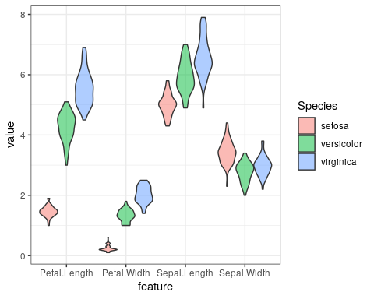
Our aim is to connect the 4 input features to the correct output class using an artificial neural network. For this task, we have chosen the following simple architecture with one input layer with 4 neurons (one for each feature), one hidden layer with 4 neurons and one output layer with 3 neurons (one for each class), all fully connected.
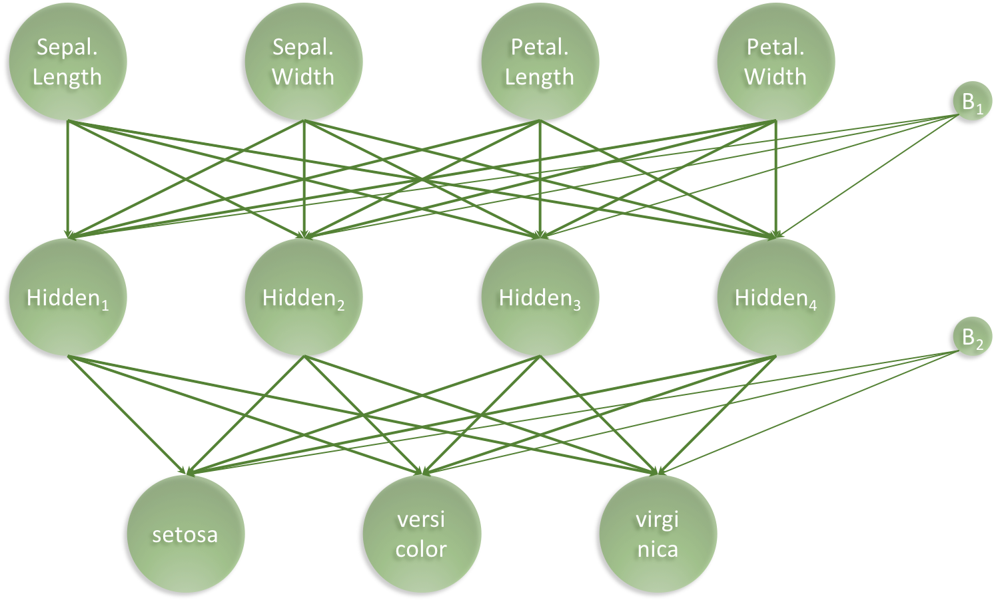
architecture_visualisation.png
Our artificial neural network will have a total of 35 parameters: 4 for each input neuron connected to the hidden layer, plus an additional 4 for the associated first bias neuron and 3 for each of the hidden neurons connected to the output layer, plus an additional 3 for the associated second bias neuron, i.e. $4×4+4+4×3+3=35$

Prepare data
We start with slightly wrangling the iris data set by renaming and scaling the features and converting character labels to numeric.
set.seed(265509)
nn_dat <- iris_tib %>%
mutate(sepal_length = scale(Sepal.Length),
sepal_width = scale(Sepal.Width),
petal_length = scale(Petal.Length),
petal_width = scale(Petal.Width),
class_label = as.numeric(Species) - 1) %>%
select(sepal_length, sepal_width, petal_length, petal_width, class_label)
nn_dat %>% head()
## # A tibble: 6 x 5
## sepal_length[,1] sepal_width[,1] petal_length[,1] petal_width[,1] class_label
## <dbl> <dbl> <dbl> <dbl> <dbl>
## 1 -0.898 1.02 -1.34 -1.31 0
## 2 -1.14 -0.132 -1.34 -1.31 0
## 3 -1.38 0.327 -1.39 -1.31 0
## 4 -1.50 0.0979 -1.28 -1.31 0
## 5 -1.02 1.25 -1.34 -1.31 0
## 6 -0.535 1.93 -1.17 -1.05 0
Then, we create indices for splitting the iris data into a training and a test data set. We set aside 20% of the data for testing.
library(tidymodels)
## ── Attaching packages ────────────────────────────────────── tidymodels 0.1.2 ──
## ✓ broom 0.7.5 ✓ recipes 0.1.15
## ✓ dials 0.0.9 ✓ rsample 0.0.9
## ✓ infer 0.5.4 ✓ tune 0.1.2
## ✓ modeldata 0.1.0.9000 ✓ workflows 0.2.1
## ✓ parsnip 0.1.5 ✓ yardstick 0.0.7
## ── Conflicts ───────────────────────────────────────── tidymodels_conflicts() ──
## x scales::discard() masks purrr::discard()
## x dplyr::filter() masks stats::filter()
## x recipes::fixed() masks stringr::fixed()
## x yardstick::get_weights() masks keras::get_weights()
## x dplyr::lag() masks stats::lag()
## x yardstick::spec() masks readr::spec()
## x recipes::step() masks stats::step()
set.seed(364)
n <- nrow(nn_dat)
n
## [1] 150
iris_parts <- nn_dat %>%
initial_split(prop = 0.8)
train <- iris_parts %>%
training()
test <- iris_parts %>%
testing()
list(train, test) %>%
map_int(nrow)
## [1] 121 29
n_total_samples <- nrow(nn_dat)
n_train_samples <- nrow(train)
n_test_samples <- nrow(test)

Create training and test data
Note that the functions in the keras package are expecting the data to be in a matrix object and not a tibble. So as.matrix is added at the end of each line.
x_train <- train %>% select(-class_label) %>% as.matrix()
y_train <- train %>% select(class_label) %>% as.matrix() %>% to_categorical()
x_test <- test %>% select(-class_label) %>% as.matrix()
y_test <- test %>% select(class_label) %>% as.matrix() %>% to_categorical()
dim(y_train)
## [1] 121 3
dim(y_test)
## [1] 29 3

Set Architecture
With the data in place, we now set the architecture of our neural network.
model <- keras_model_sequential()
model %>%
layer_dense(units = 4, activation = 'relu', input_shape = 4) %>%
layer_dense(units = 3, activation = 'softmax')
model %>% summary
## Model: "sequential"
## ________________________________________________________________________________
## Layer (type) Output Shape Param #
## ================================================================================
## dense_1 (Dense) (None, 4) 20
## ________________________________________________________________________________
## dense (Dense) (None, 3) 15
## ================================================================================
## Total params: 35
## Trainable params: 35
## Non-trainable params: 0
## ________________________________________________________________________________
Next, the architecture set in the model needs to be compiled.
model %>% compile(
loss = 'categorical_crossentropy',
optimizer = optimizer_rmsprop(),
metrics = c('accuracy')
)

Train the Artificial Neural Network
Lastly we fit the model and save the training progress in the history object.
Try changing the validation_split from 0 to 0.2 to see the validation_loss.
history <- model %>% fit(
x = x_train, y = y_train,
epochs = 200,
batch_size = 20,
validation_split = 0.2
)
plot(history) +
ggtitle("Training a neural network based classifier on the iris data set") +
theme_bw()
## `geom_smooth()` using formula 'y ~ x'
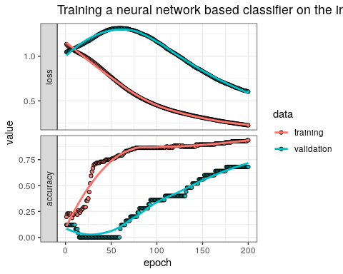

Evaluate Network Performance
The final performance can be obtained like so.
perf <- model %>% evaluate(x_test, y_test)
print(perf)
## loss accuracy
## 0.3694951 0.8275862
For the next plot the predicted and true values need to be in a vector. Note that the true values need to be unlisted before putting them into a numeric vector.
classes <- iris %>% pull(Species) %>% unique()
y_pred <- model %>% predict_classes(x_test)
y_true <- test %>% select(class_label) %>% unlist() %>% as.numeric()
tibble(y_true = classes[y_true + 1], y_pred = classes[y_pred + 1],
Correct = ifelse(y_true == y_pred, "Yes", "No") %>% factor) %>%
ggplot(aes(x = y_true, y = y_pred, colour = Correct)) +
geom_jitter() +
theme_bw() +
ggtitle(label = "Classification Performance of Artificial Neural Network",
subtitle = str_c("Accuracy = ",round(perf[2],3)*100,"%")) +
xlab(label = "True iris class") +
ylab(label = "Predicted iris class")
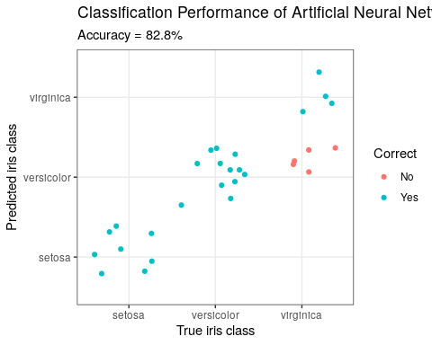
library(gmodels)
CrossTable(y_pred, y_true,
prop.chisq = FALSE, prop.t = FALSE, prop.r = FALSE,
dnn = c('predicted', 'actual'))
##
##
## Cell Contents
## |-------------------------|
## | N |
## | N / Col Total |
## |-------------------------|
##
##
## Total Observations in Table: 29
##
##
## | actual
## predicted | 0 | 1 | 2 | Row Total |
## -------------|-----------|-----------|-----------|-----------|
## 0 | 8 | 0 | 0 | 8 |
## | 1.000 | 0.000 | 0.000 | |
## -------------|-----------|-----------|-----------|-----------|
## 1 | 0 | 12 | 5 | 17 |
## | 0.000 | 1.000 | 0.556 | |
## -------------|-----------|-----------|-----------|-----------|
## 2 | 0 | 0 | 4 | 4 |
## | 0.000 | 0.000 | 0.444 | |
## -------------|-----------|-----------|-----------|-----------|
## Column Total | 8 | 12 | 9 | 29 |
## | 0.276 | 0.414 | 0.310 | |
## -------------|-----------|-----------|-----------|-----------|
##
##

Conclusion
I hope this illustrated just how easy it is to get started building artificial neural network using Keras and TensorFlow in R. With relative ease, we created a 3-class predictor with an accuracy of 100%. This was a basic minimal example. The network can be expanded to create Deep Learning networks and also the entire TensorFlow API is available.
Enjoy and Happy Learning!
Leon
Thanks again Leon, this was awesome!!!

