Accuracy of Precipitation Forecasts:
Finding the Right Threshold for what is Considered Rain

Darren Keeley¹, Eric A. Suess¹
¹California State University East Bay, 25800 Carlos Bee Boulevard, Hayward, CA 94542 darren.keeley@csueastbay.edu, eric.suess@csueastbay.edu

Abstract

Accurately predicting the rain is a fundamental component of weather forecasting. However, looking at the data provided for the Data Expo challenge, forecasts were consistently underpredicting the proportion of rainy days. The default threshold in inches of rain for what is considered a rainy day is 0.01 inches or more as defined by the National Weather Service. This paper found that adjusting the threshold for each city dramatically increases probability of precipitation forecast accuracies, and that generally across the U.S. a threshold of 0.07 inches is better than 0.01.

Key Words: 2018 ASA Data Expo

1. Introduction

The United States harbors regions of vastly different climates. The weather varies to such a degree that it may be beneficial to judge and measure it differently for each region. Indeed, rainfall is one of the most variable characteristics, and what one city considers a rainy day may not faze another.

In this paper different thresholds for rainy days are explored across 108 cities in the US. The impact this has the accuracy of precipitation forecasts is analyzed. The similarities amongst the least accurate cities are explored, as well as those for the most accurate. R was utilized for the analytics in this project.

This article is one of several closely related articles from the 2018 Data Expo on weather forecasting. For more details please refer to the editorial (Cook, 2013).*** What is this statement for?
2. Measuring Precipitation Forecast Accuracy

The original data set contained 3,191,972 daily weather forecasts and 130,457 historical data points from July 2014 to September 2017. Forecasts consisted of two types, temperature and probability of precipitation, and only the latter is discussed in this paper. The forecast distances ranged from same day to seven days out. The historical dataset contained many more metrics than those in the forecast dataset, including dew point, humidity and inches of precipitation.

Forecasts for rain were given by Probability of Precipitation (PoP), with values ranging from 0 to 100 by increments of 10. To assess the accuracy of these probabilities, the actual occurrence rate for rain was compared to the given forecast probability for each increment. For instance,

- Looking at the proportion of rainy days for days with a forecast of 70% PoP, if it rained on 70% of those days, then the forecasts were accurate.
- If 90% of those days rained, then the forecasts under-predicted the rain with an error of 20.
- And if only 40% of those days were rainy, then the forecast over-predicted the rain with an error of -30.

3. The Weather is Usually Wetter than Predicted

Using this metric of “Rain Error,” precipitation forecasts generally under-predict the rain, with the weather being wetter than expected across nearly the entirety of America save the Rocky Mountains and cities adjacent to them. In the map, blue indicates more rainy days than predicted and orange means less. White is relatively equal numbers of days.
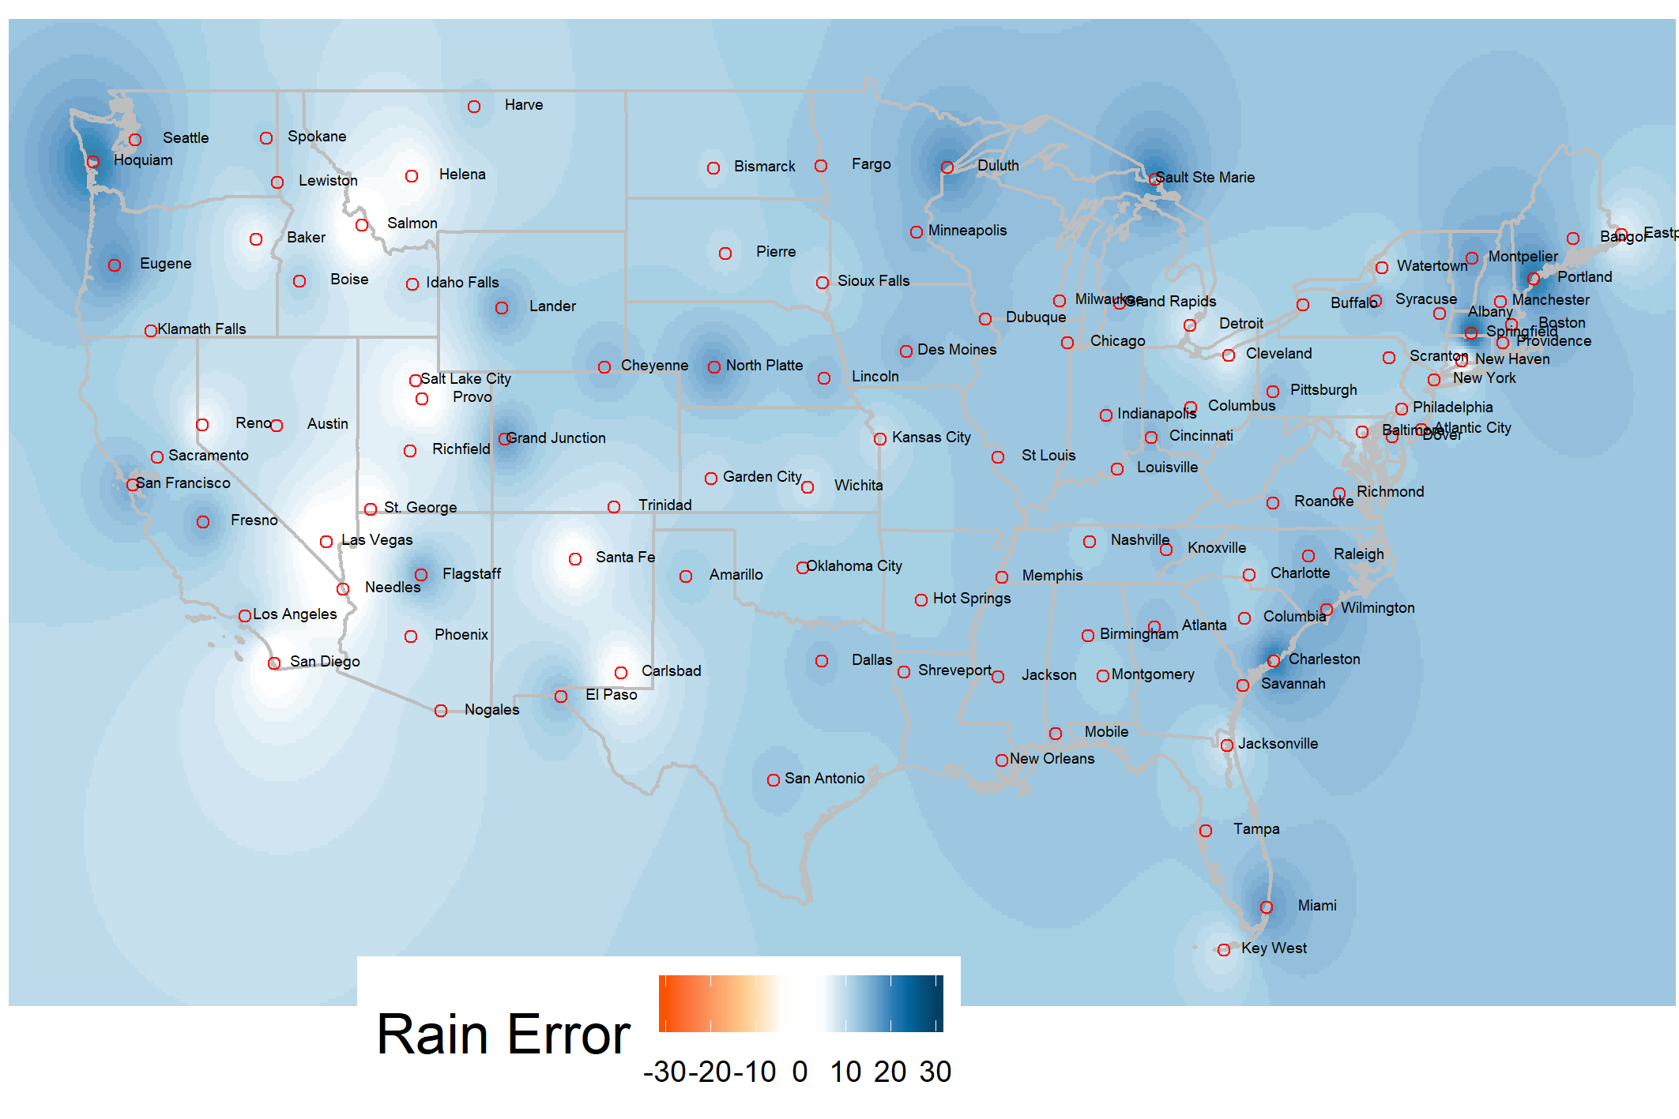
Figure 1: Weather is usually wetter than predicted. In the map, blue indicates more rainy days than predicted on average. While there was only data on the cities, the precipitation errors in the spaces between them were interpolated to aid with the illustration. The interpolated errors are to be taken lightly, and those outside the boundaries of the US have no meaning.

Part of the issue may be how rain is defined. According to the National Weather Service (NWS, from which the data was procured) 0.01 inches of precipitation or more constitutes rain. Such small amounts of rain could be too small to predict or even be reasonably considered rain. If these very light rainy days are safe to ignore, then perhaps it would serve better to not try to predict them at all. Raising the threshold for how many inches of rain constitutes a rainy day would accomplish this, and is what is explored from hereon.

In the graph, the black dashed line indicates perfect forecasts, where PoP matches the proportion of rainy days. Being above the line is rainier, and below is drier. Looking at the graph showing different cut points, or thresholds, 0.07 or more inches seems to yield smaller forecast errors: most of the time the proportion of rainy days is accurately predicted or otherwise over-predicted. Over-predicting the rain may be a less egregious error than under-predicting it, given the latter would cause plans to be canceled, and in the former’s case plans would never be made at all.

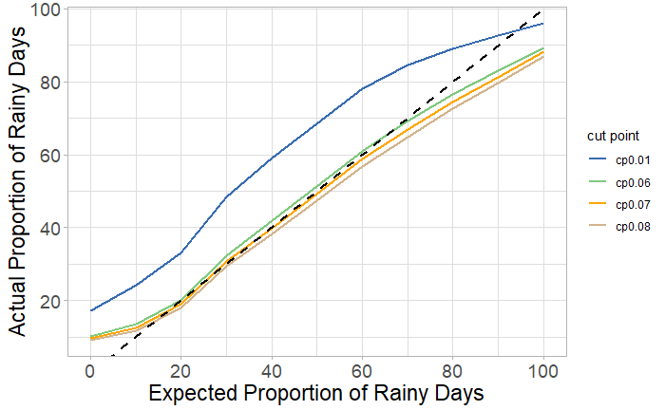

Figure 2: Above the dashed line is more rain than predicted.

The two maps that follow illustrate the overall improvement in forecast accuracy after adjusting the threshold. Here the absolute error is used, so there isn’t a distinction between cities that are drier or wetter than forecasted. This is also a better metric for accuracy since negative and positive errors won’t cancel each other out. Raising the cut point to 0.07 shows improvement in most areas, though cities in the Rocky Mountains worsened because they were dry or already accurate. 0.07 may be reasonable across most cities if one could stomach unannounced light drizzle.

The seven cities with the highest average rain error are labeled. Most of them are located on the coasts. The exact values can be found in Figure 4.

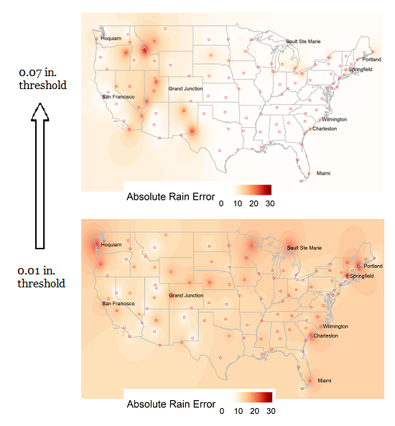

Figure 3: When cut point is raised from 0.01 to 0.07 in., days with barely any rain are not counted as rainy. Absolute error falls except for cities in the Rocky Mountains which were dry or already accurate. The top 10 least accurate cities are labeled, minus Honolulu.

4. The Effects of Forecast Distance

Longer forecast distances have an adverse effect on accuracy. Absolute rain error tends to rise as the distance increases, as shown in figure 4.

However, the initial problem remains: rain is still consistently underpredicted, no matter the forecast distance (figure 5). As such, forecasts of all distances will continue to be included in the calculation of forecast accuracy.

Forecast Distance | Rain Error
0 days out | 13.58
1 day out | 12.18
2 days out | 13.20
3 days out | 14.11
4 days out | 17.26
5 days out | 14.33
6 days out | 15.30

Figure 4: Errors in precipitation forecasts tend to increase as the forecast distance increases.

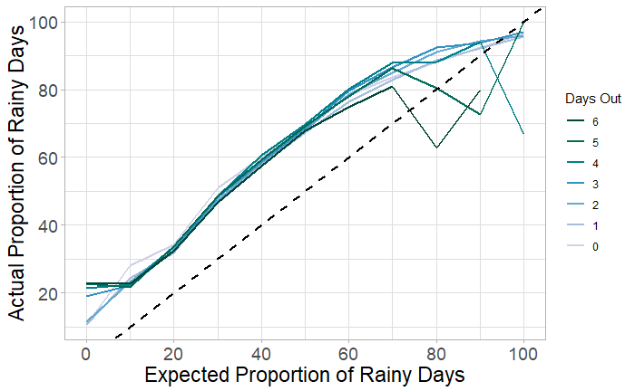

Figure 5: All forecast distances follow the same pattern of underpredicting precipitation.

5. What are the Characteristics of the Least (and Most) Accurate Cities?

There is moderate correlation between the number of rainy days per year and rain error, with a value of 0.4834. As shown in figure 6, this value may be heavily influenced by the four cities with very high errors and number of rainy days. Without them, the correlation much weaker at 0.2612.
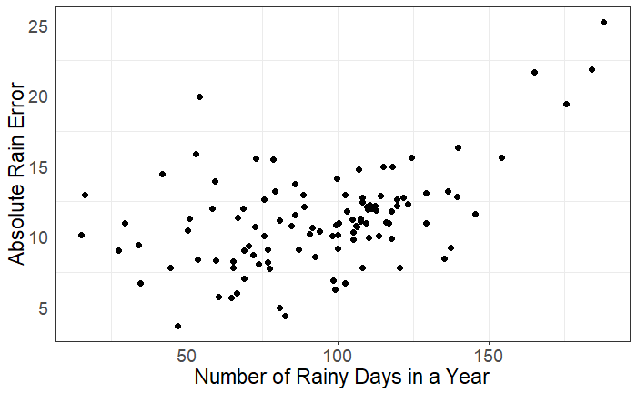

Figure 6: There is moderate correlation between how often it rains in a city and its rain error.

The 5 least accurate cities are shown in figure 7. These error-prone cities experience rain often, but not in large amounts. They are the rainiest cities in terms of days but not necessarily in inches. Springfield, for instance, experiences an average of 188 rainy days per year with only 0.22 in. per day, corresponding to normalized values of 2.8151 and -0.9232, respectively.

Honolulu is a special case that only seems less rainy due to 29.2% of its days having “trace” amounts of rain, where trace is less than 0.01 inches and thus not counted as rain. The median proportion of trace days is 9.6%.

Figure 8 displays the 10 most accurate cities. All of them are relatively unremarkable regarding the number of rainy days and the average inches of precipitation per rainy day, being well within 2 standard deviations of either mean.
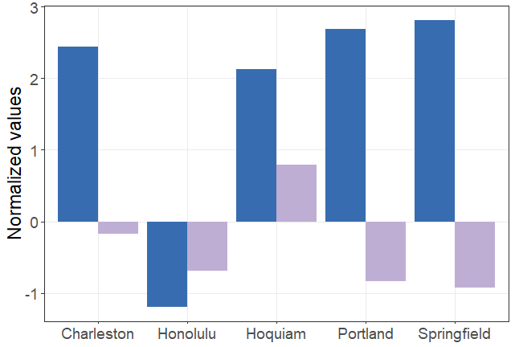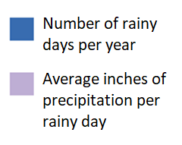

Figure 7: The cities with the highest errors experience rain often, but not in necessarily high amounts.

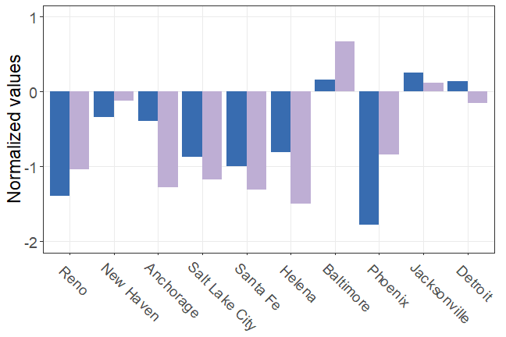

Figure 8: The cities with the highest errors experience rain often, but not in necessarily high amounts.

6. A Unique Threshold for Each City

Changing the cut point from 0.01 to 0.07 helps most cities. Forecasts from Springfield and Portland, the two least accurate cities, become much more precise when 0.06 inches of rain and below are ignored. Seattle and Sacramento are two cities that don’t rank highly in terms of errors, and they also benefit from the change.

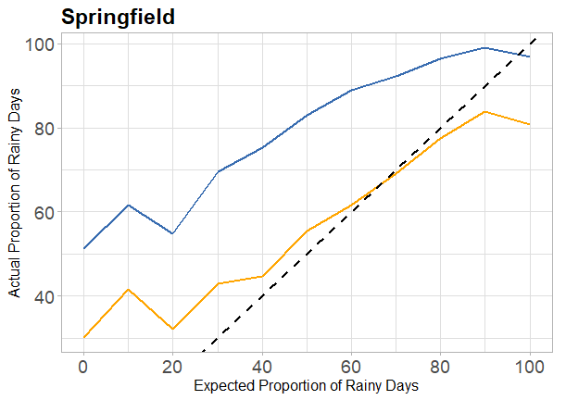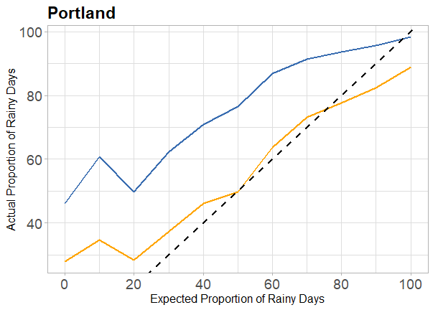
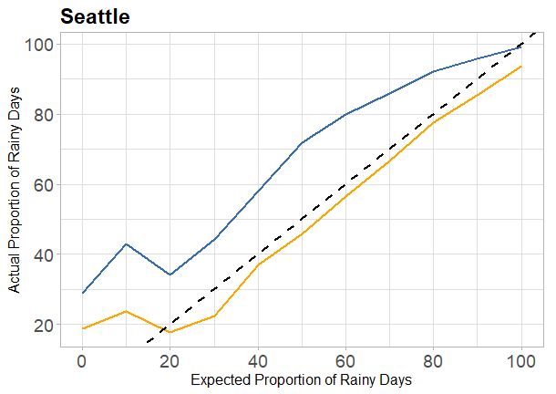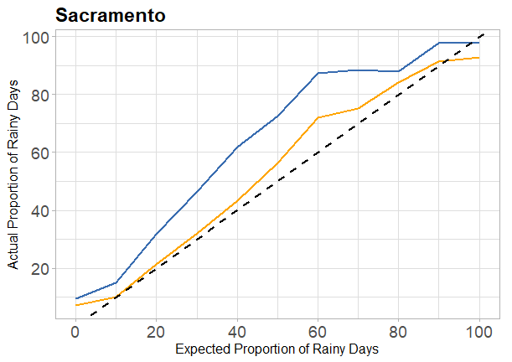
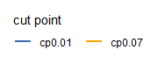

Figure 9: The higher cut point improves accuracy for most cities

However, changing the cut point does not help every city. Honolulu has an exceptional number of trace rain days, making it seemingly drier by these metrics. Salmon, located in the Rocky Mountains, is a very dry city with few rainy days.

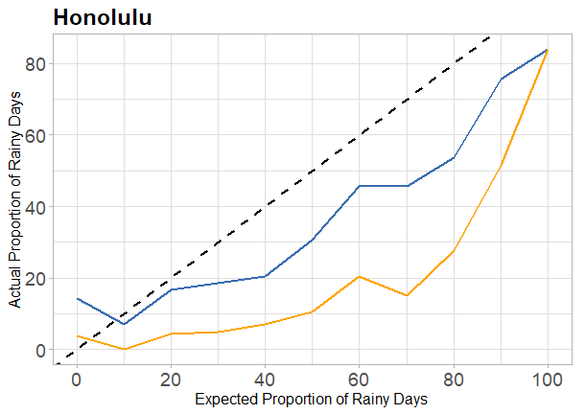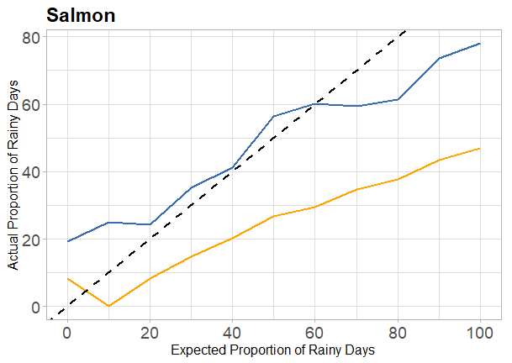

Figure 10: For some cities, the original cut point should be kept.

The cut off for what constitutes rain can drastically alter the accuracy of precipitation forecasts. Local meteorologists should consider what cut point makes sense for their area, as some folks may consider 0.01 inches of rain as “rainy” and others not.

7. Summary

Changing the precipitation threshold for rainy days is a simple and actionable way to improve rain forecasts. For cities that experience very light rain often, discounting those days may not adversely affect the populace and would save rain notifications for heavier drizzles. Not every city needs an adjustment, and drier areas could benefit from greater precision in precipitation detection.

8. Acknowledgements

The authors are grateful to the organizers of the 2018 Joint Statistical Meetings and the ASA sections of the Statistical Graphics and Statistical Computing for the opportunity to create and share our work.

References

Cook D (2013), The 2011 Data Expo of the American Statistical Association, Computational Statistics; this issue

Dubner, S. J. (2008, April 21). How Valid Are T.V. Weather Forecasts? Retrieved June 16, 2018, from http://freakonomics.com/2008/04/21/how-valid-are-tv-weather-forecasts/?c_page=2#comments_archived

Lee, N. (2014, December 1). Rainfall interpolation using ANN. Retrieved June 16, 2018, from https://stat.ethz.ch/pipermail/r-sig-geo/2014-December/022087.html

Marsh, D. (2015, June 05). What Does Probability of Precipitation Mean? Retrieved from https://www.weather.gov/lmk/pops

Suess, E. A., & Trumbo, B. E. (2010). Introduction to Probability, Simulation and Gibbs sampling with R. New York: Springer.

Yau, N. C. (2011). Visualize this the FlowingData guide to design, visualization, and statistics. Indianapolis, IN: Wiley.

Appendix

Figure 1

 | City | RE
1 | Springfield | 29.60818
2 | Portland | 25.96182
3 | Hoquiam | 24.61273
4 | Honolulu | 23.56
5 | Charleston | 23.15182
6 | Miami | 21.55727
7 | San Francisco | 20.43545
8 | Sault Ste Marie | 19.212
9 | Wilmington | 19.184
10 | Grand Junction | 18.97636
11 | North Platte | 18.58727
12 | Duluth | 18.523
13 | Raleigh | 18.231
14 | Minneapolis | 17.53364
15 | Fresno | 17.403
16 | Des Moines | 17.34273
17 | Lander | 17.24909
18 | Flagstaff | 17.20818
19 | Montpelier | 17.18545
20 | Dallas | 16.864
21 | Seattle | 16.76818
22 | Cheyenne | 16.76273
23 | Dubuque | 16.437
24 | Las Vegas | 16.073
25 | Atlantic City | 15.858
26 | Pittsburgh | 15.67091
27 | Chicago | 15.65364
28 | Cincinnati | 15.38
29 | Salmon | 15.36273
30 | Knoxville | 15.33727
31 | Providence | 15.33727
32 | Bangor | 15.32455
33 | Boston | 15.309
34 | Indianapolis | 15.292
35 | Eugene | 15.18091
36 | Atlanta | 15.175
37 | Lewiston | 15.10091
38 | New Orleans | 15.077
39 | Richfield | 15.07545
40 | Amarillo | 15.05545
41 | Richmond | 14.991
42 | Louisville | 14.94545
43 | Roanoke | 14.89
44 | Jackson | 14.85
45 | Syracuse | 14.829
46 | Lincoln | 14.81
47 | Nogales | 14.57455
48 | El Paso | 14.48727
49 | Memphis | 14.46
50 | Birmingham | 14.35364
51 | Kansas City | 14.26909
52 | Tampa | 14.23545
53 | Columbus | 14.21364
54 | Albany | 14.08455
55 | Los Angeles | 14.015
56 | St Louis | 13.99909
57 | Milwaukee | 13.979
58 | Grand Rapids | 13.90545
59 | Savannah | 13.88727
60 | Mobile | 13.79182
61 | Fargo | 13.71636
62 | New York | 13.67818
63 | Pierre | 13.666
64 | Hot Springs | 13.553
65 | Sacramento | 13.53273
66 | Spokane | 13.52818
67 | Manchester | 13.52
68 | Shreveport | 13.51727
69 | Needles | 13.326
70 | Montgomery | 13.27636
71 | Nashville | 13.21455
72 | Columbia | 13.21
73 | Boise | 13.152
74 | Dover | 13.14455
75 | Scranton | 13.12636
76 | Philadelphia | 13.01364
77 | St. George | 12.96091
78 | Wichita | 12.804
79 | Buffalo | 12.549
80 | Charlotte | 12.52455
81 | Oklahoma City | 12.39636
82 | Sioux Falls | 12.18091
83 | San Diego | 12.138
84 | San Antonio | 12.014
85 | Idaho Falls | 11.94727
86 | Key West | 11.94273
87 | Watertown | 11.82455
88 | Provo | 11.69818
89 | Garden City | 11.61
90 | Trinidad | 11.04091
91 | Klamath Falls | 10.82364
92 | Harve | 10.58182
93 | Eastport | 10.547
94 | Cleveland | 10.101
95 | Austin | 10.01364
96 | Carlsbad | 10.005
97 | Bismarck | 9.698182
98 | Baker | 9.366364
99 | Detroit | 8.758182
100 | Jacksonville | 8.569091
101 | Phoenix | 8.287273
102 | Baltimore | 8.155455
103 | Helena | 8.105455
104 | Santa Fe | 7.611
105 | Salt Lake City | 6.128182
106 | Anchorage | 5.502727
107 | New Haven | 5.476364
108 | Reno | 5.467

View publication stats

