Zipped R Projects
One of the main ways to share your R Projects with others is to send them a zipped R Project. If you send them a zipped R Project once it is unzipped the person you have sent it to will have a new directory containing all the files in your R Project.
I ask you to follow this process for submitting all assignments in this class.

Step 1: Create an R project in a directory
lastname_firstname_Stat650_hw1
for each assignment the last part of the directory should be changed.
To create an R Project click on the Project: (None) in the upper right-hand side of RStudio.
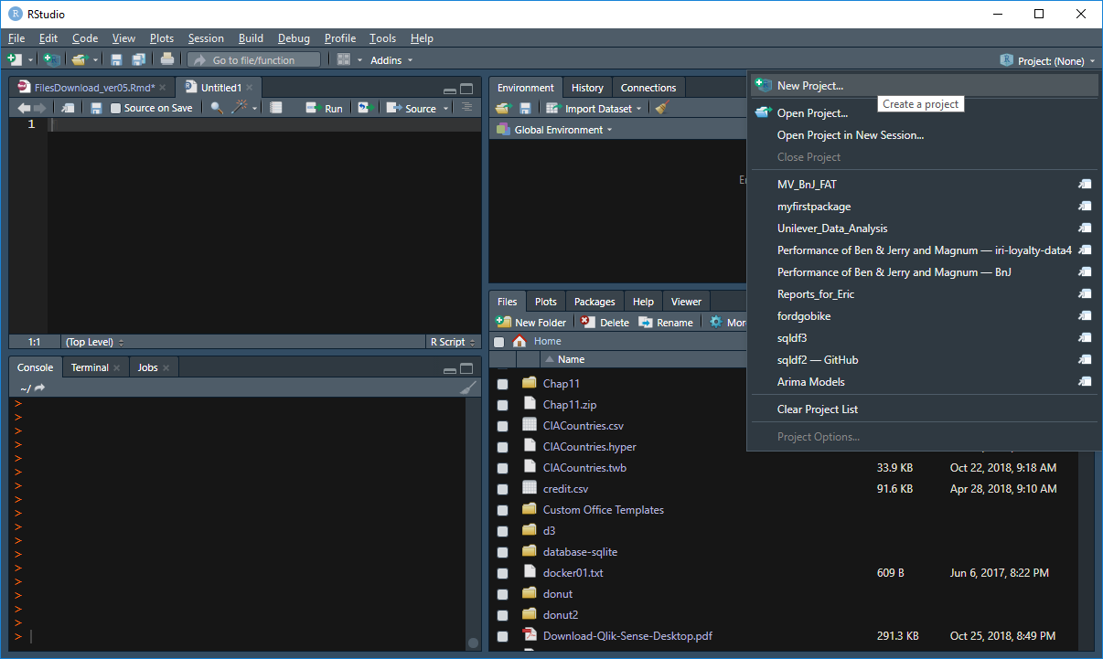

Next select New Project > New Directory > New Project

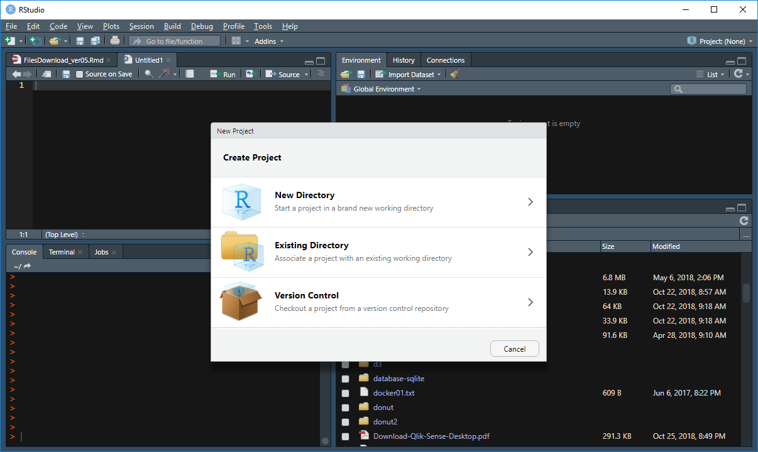

Enter the name of your R Project in the first box, Directory name:
You should enter: lastname_firstname_Stat650_hw1
And then click Create Project

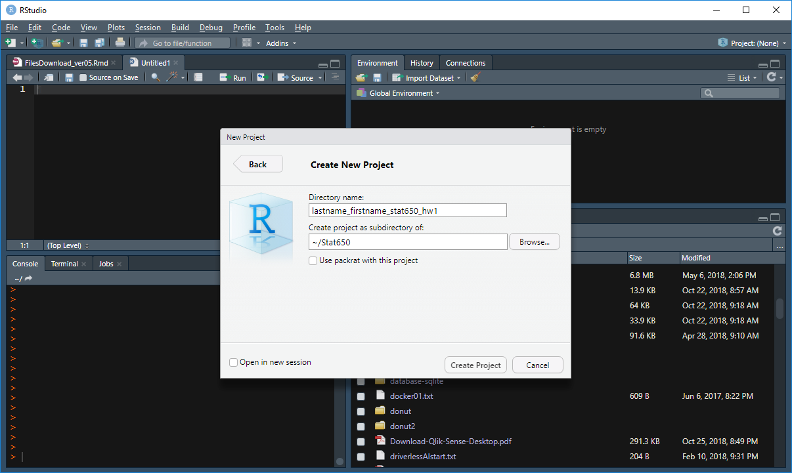

Step 2: Create your R Notebook with the filename
lastname_firstname_Stat650_hw1.Rmd

File > New File > R Notebook

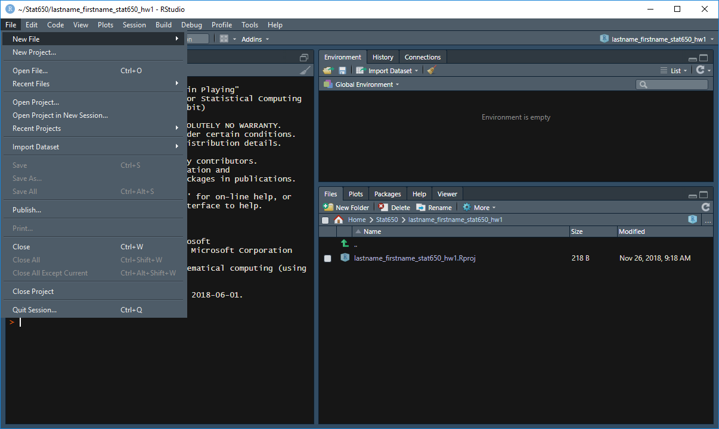

Now save your notebook into your R Project. File > Save as

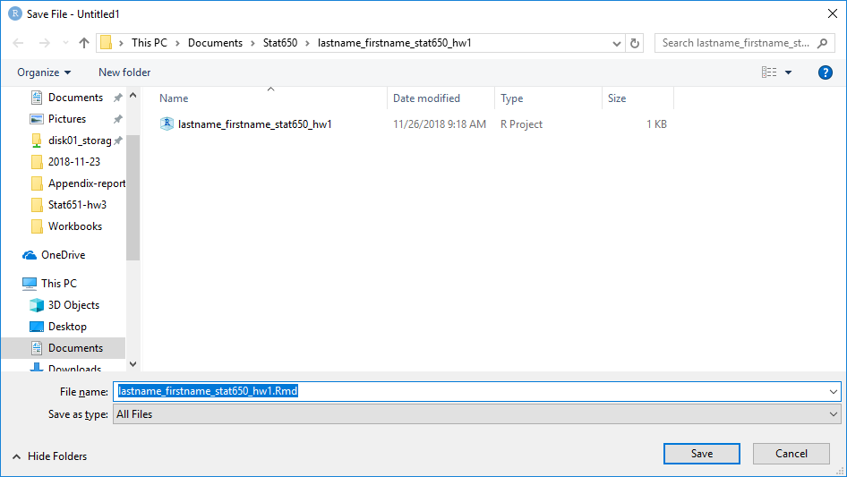
Now you should have the .Rmd file in your R Project directory.

Step 3: Create a data subdirectory.

In the lower right part of RStudio select Files > New Folder and then type data and OK.

Now you should also have a data subdirectory.
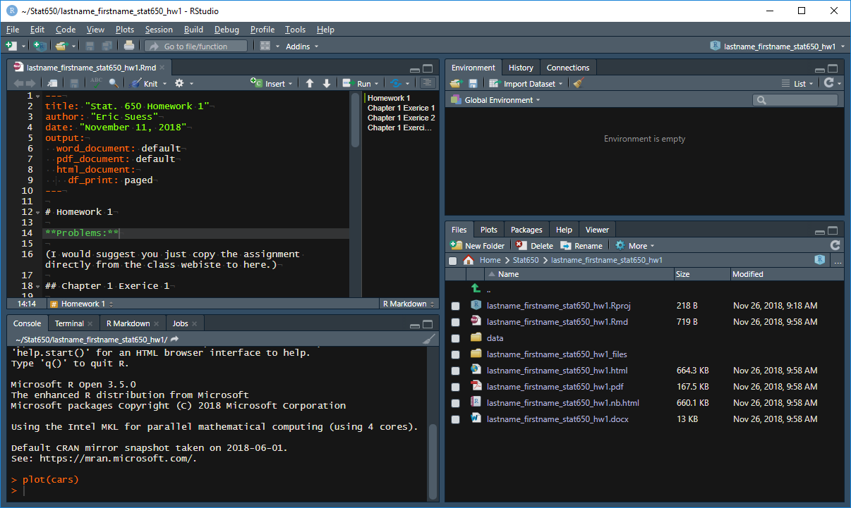

Step 4: After completing your work, now you should zip your R Project directory into a file that will be called lastname_firstname_Stat650_hw1.zip

To do this locate your R Project directory in the Windows Explorer. In my case it is in My Documents directory under my Stat650 subdirectory.
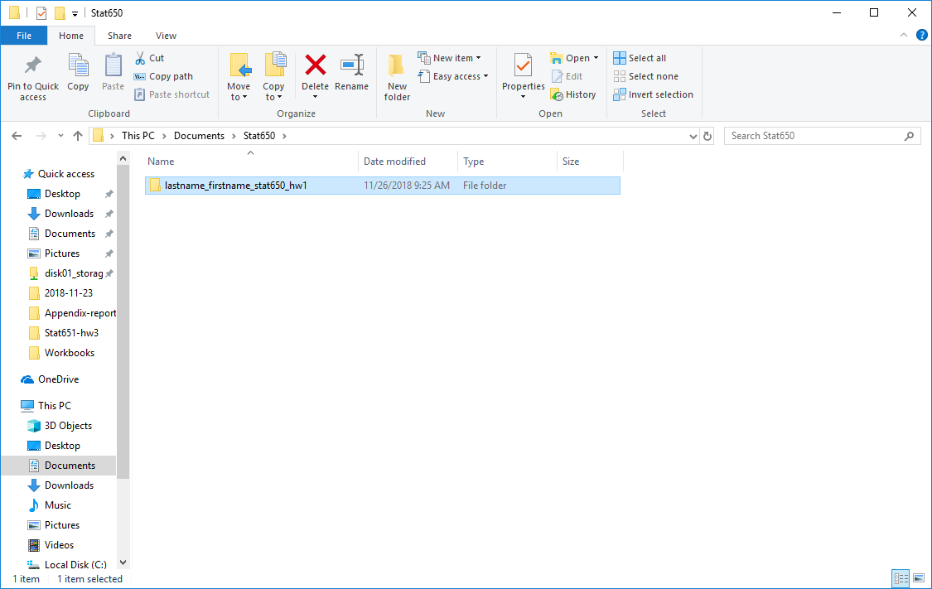

To zip your R Project

Right-click > Send to > Compressed (zipped) folder

Now you should have a zipped version of your R Project to submit through Blackboard.

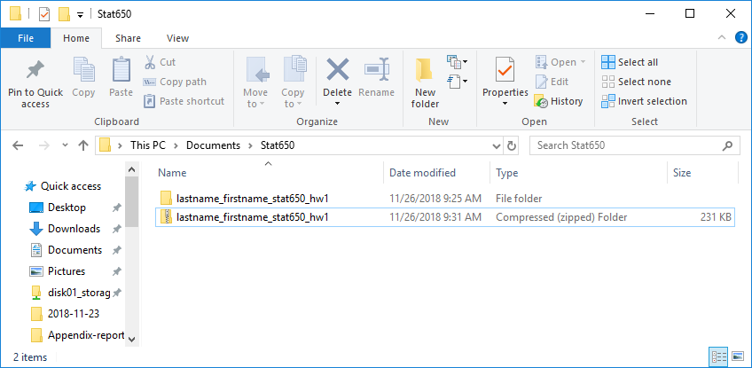

Final step: Make sure your R.md file runs and that you have created an .html version of your work and a .docx (or .pdf is you know how to do this). I will not be running your code to grade your work. It is your responsibility to submit your completed work, which means having everything together so I can see it.

Reason for this structure:
As the instructor of the course I need to collect your homework an everyone else’s homework in the class. The way I work with the files you submit.
- I bulk download all of the .zipped files from Backboard.
- Then I unzip all the files in my Homework grading directory.
- What I get is an alphabetical collection of R Project directories to look at one by one that is in the same order as the grade sheet in Blackboard.

