Unite Examples

Some Examples of spread, gather, unite, separate.
See the R Studio Data Wrangling Cheatsheet.
See the R Studio ggplot Cheatsheet.
library(tidyverse)

The examples from the cheatsheet.
mydata <- data_frame(
a = 1:3,
b = 4:6
)
mydata
## # A tibble: 3 x 2
## a b
## <int> <int>
## 1 1 4
## 2 2 5
## 3 3 6
Arrange the data.
arrange(mydata, desc(a))
## # A tibble: 3 x 2
## a b
## <int> <int>
## 1 3 6
## 2 2 5
## 3 1 4
Rename the data.
mydata <- rename(mydata, x = a, y = b)
mydata
## # A tibble: 3 x 2
## x y
## <int> <int>
## 1 1 4
## 2 2 5
## 3 3 6
arrange(mydata, desc(x))
## # A tibble: 3 x 2
## x y
## <int> <int>
## 1 3 6
## 2 2 5
## 3 1 4
mydata %>% mutate(x.prop = x/sum(x), x.cum.prop = cumsum(x)/sum(x), y.prop = y/sum(y), y.cum.prop = cumsum(y)/sum(y)) %>%
select(x, x.prop, x.cum.prop, y, y.prop, y.cum.prop)
## # A tibble: 3 x 6
## x x.prop x.cum.prop y y.prop y.cum.prop
## <int> <dbl> <dbl> <int> <dbl> <dbl>
## 1 1 0.167 0.167 4 0.267 0.267
## 2 2 0.333 0.5 5 0.333 0.6
## 3 3 0.5 1 6 0.4 1

Example, page 27, Problem 2.2, Ott 3rd Edition
imports <- data_frame(
Year = c(1979:1986),
Import = c(17518,15491,19898,16663,17061,26171,23650,19650)
)
imports
## # A tibble: 8 x 2
## Year Import
## <int> <dbl>
## 1 1979 17518
## 2 1980 15491
## 3 1981 19898
## 4 1982 16663
## 5 1983 17061
## 6 1984 26171
## 7 1985 23650
## 8 1986 19650
imports.wide <- spread(imports, key = Year, value = Import)
imports.wide
## # A tibble: 1 x 8
## `1979` `1980` `1981` `1982` `1983` `1984` `1985` `1986`
## <dbl> <dbl> <dbl> <dbl> <dbl> <dbl> <dbl> <dbl>
## 1 17518 15491 19898 16663 17061 26171 23650 19650
imports.narrow <- gather(imports.wide, key = "Year.New", value = Import.New)
imports.narrow
## # A tibble: 8 x 2
## Year.New Import.New
## <chr> <dbl>
## 1 1979 17518
## 2 1980 15491
## 3 1981 19898
## 4 1982 16663
## 5 1983 17061
## 6 1984 26171
## 7 1985 23650
## 8 1986 19650
imports.narrow <- imports.narrow %>% mutate(Year.New = as.integer(Year.New))
imports.narrow
## # A tibble: 8 x 2
## Year.New Import.New
## <int> <dbl>
## 1 1979 17518
## 2 1980 15491
## 3 1981 19898
## 4 1982 16663
## 5 1983 17061
## 6 1984 26171
## 7 1985 23650
## 8 1986 19650
imports %>% ggplot(aes(x=Year, y=Import)) +
geom_col()
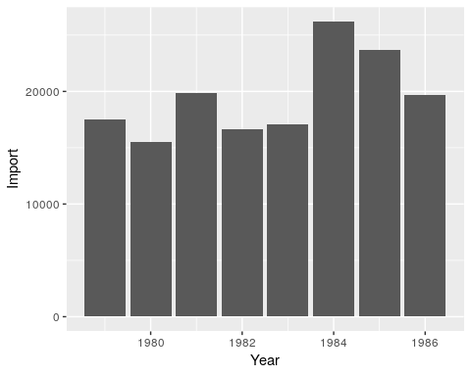
imports %>% ggplot(aes(x=Year, y=Import)) +
geom_line()
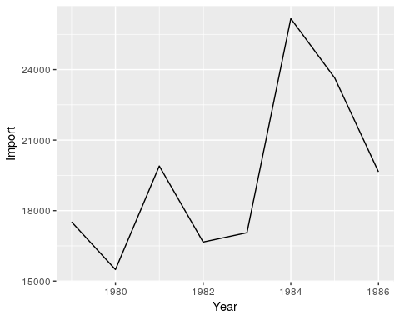

Example, page 28, Problem 2.4, Ott 3rd Edition
GNP.1985 <- data_frame(
Year = c(1985,1985,1985,1985),
Quarter = c("I","II","III","IV"),
GNP = c(3910,3961,4017,4067),
DPI = c(2505,2532,2503,2533)
)
GNP.1985
## # A tibble: 4 x 4
## Year Quarter GNP DPI
## <dbl> <chr> <dbl> <dbl>
## 1 1985 I 3910 2505
## 2 1985 II 3961 2532
## 3 1985 III 4017 2503
## 4 1985 IV 4067 2533
GNP.1986 <- data_frame(
Year = c(1986,1986,1986,1986),
Quarter = c("I","II","III","IV"),
GNP = c(4137,4203,4266,4308),
DPI = c(2536,2555,2579,2589)
)
GNP.1986
## # A tibble: 4 x 4
## Year Quarter GNP DPI
## <dbl> <chr> <dbl> <dbl>
## 1 1986 I 4137 2536
## 2 1986 II 4203 2555
## 3 1986 III 4266 2579
## 4 1986 IV 4308 2589
GNP <- bind_rows(GNP.1985, GNP.1986)
GNP
## # A tibble: 8 x 4
## Year Quarter GNP DPI
## <dbl> <chr> <dbl> <dbl>
## 1 1985 I 3910 2505
## 2 1985 II 3961 2532
## 3 1985 III 4017 2503
## 4 1985 IV 4067 2533
## 5 1986 I 4137 2536
## 6 1986 II 4203 2555
## 7 1986 III 4266 2579
## 8 1986 IV 4308 2589
GNP.wide <- GNP %>% select(Year, Quarter, GNP) %>%
spread(key = Quarter, value = GNP )
GNP.wide
## # A tibble: 2 x 5
## Year I II III IV
## <dbl> <dbl> <dbl> <dbl> <dbl>
## 1 1985 3910 3961 4017 4067
## 2 1986 4137 4203 4266 4308
GNP.narrow <- GNP.wide %>%
gather(key = Quarter, value = GNP, I,II,III, IV ) %>%
arrange(Year)
GNP.narrow
## # A tibble: 8 x 3
## Year Quarter GNP
## <dbl> <chr> <dbl>
## 1 1985 I 3910
## 2 1985 II 3961
## 3 1985 III 4017
## 4 1985 IV 4067
## 5 1986 I 4137
## 6 1986 II 4203
## 7 1986 III 4266
## 8 1986 IV 4308
GNP %>% ggplot(aes(x= factor(Year), y = GNP, fill = Quarter)) +
geom_bar(stat = "identity", position = "dodge") +
labs(x = "Year")
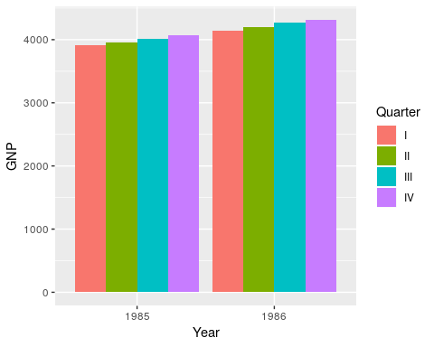

Example, page 30, Problem 2.14, Ott 3rd Edition
SAT <- data_frame(
GT = c("Male, Math", "Female, Math", "Male, Verbal", "Female, Verbal"),
"Year 1967" = c(514,467,463,486),
"Year 1970" = c(509,465,459,461),
"Year 1975" = c(495,449,437,431),
"Year 1980" = c(491,443,428,420),
"Year 1983" = c(493,445,430,420)
)
SAT
## # A tibble: 4 x 6
## GT `Year 1967` `Year 1970` `Year 1975` `Year 1980` `Year 1983`
## <chr> <dbl> <dbl> <dbl> <dbl> <dbl>
## 1 Male, Math 514 509 495 491 493
## 2 Female, Math 467 465 449 443 445
## 3 Male, Verbal 463 459 437 428 430
## 4 Female, Ver… 486 461 431 420 420
SAT.wide <- SAT %>% rename("1967" = "Year 1967", "1970" = "Year 1970", "1975" = "Year 1975", "1980" = "Year 1980", "1983" = "Year 1983")
SAT.wide
## # A tibble: 4 x 6
## GT `1967` `1970` `1975` `1980` `1983`
## <chr> <dbl> <dbl> <dbl> <dbl> <dbl>
## 1 Male, Math 514 509 495 491 493
## 2 Female, Math 467 465 449 443 445
## 3 Male, Verbal 463 459 437 428 430
## 4 Female, Verbal 486 461 431 420 420
SAT.narrow <- SAT.wide %>% gather( key = Year, value = Score, "1967", "1970", "1975", "1980", "1983" )
SAT.narrow
## # A tibble: 20 x 3
## GT Year Score
## <chr> <chr> <dbl>
## 1 Male, Math 1967 514
## 2 Female, Math 1967 467
## 3 Male, Verbal 1967 463
## 4 Female, Verbal 1967 486
## 5 Male, Math 1970 509
## 6 Female, Math 1970 465
## 7 Male, Verbal 1970 459
## 8 Female, Verbal 1970 461
## 9 Male, Math 1975 495
## 10 Female, Math 1975 449
## 11 Male, Verbal 1975 437
## 12 Female, Verbal 1975 431
## 13 Male, Math 1980 491
## 14 Female, Math 1980 443
## 15 Male, Verbal 1980 428
## 16 Female, Verbal 1980 420
## 17 Male, Math 1983 493
## 18 Female, Math 1983 445
## 19 Male, Verbal 1983 430
## 20 Female, Verbal 1983 420
SAT.narrow2 <- SAT.narrow %>% separate(GT, c("Gender", "Type"))
SAT.narrow2
## # A tibble: 20 x 4
## Gender Type Year Score
## <chr> <chr> <chr> <dbl>
## 1 Male Math 1967 514
## 2 Female Math 1967 467
## 3 Male Verbal 1967 463
## 4 Female Verbal 1967 486
## 5 Male Math 1970 509
## 6 Female Math 1970 465
## 7 Male Verbal 1970 459
## 8 Female Verbal 1970 461
## 9 Male Math 1975 495
## 10 Female Math 1975 449
## 11 Male Verbal 1975 437
## 12 Female Verbal 1975 431
## 13 Male Math 1980 491
## 14 Female Math 1980 443
## 15 Male Verbal 1980 428
## 16 Female Verbal 1980 420
## 17 Male Math 1983 493
## 18 Female Math 1983 445
## 19 Male Verbal 1983 430
## 20 Female Verbal 1983 420
SAT.narrow3 <- SAT.narrow2 %>% unite(GT, c("Gender", "Type"), sep="_")
SAT.narrow3
## # A tibble: 20 x 3
## GT Year Score
## <chr> <chr> <dbl>
## 1 Male_Math 1967 514
## 2 Female_Math 1967 467
## 3 Male_Verbal 1967 463
## 4 Female_Verbal 1967 486
## 5 Male_Math 1970 509
## 6 Female_Math 1970 465
## 7 Male_Verbal 1970 459
## 8 Female_Verbal 1970 461
## 9 Male_Math 1975 495
## 10 Female_Math 1975 449
## 11 Male_Verbal 1975 437
## 12 Female_Verbal 1975 431
## 13 Male_Math 1980 491
## 14 Female_Math 1980 443
## 15 Male_Verbal 1980 428
## 16 Female_Verbal 1980 420
## 17 Male_Math 1983 493
## 18 Female_Math 1983 445
## 19 Male_Verbal 1983 430
## 20 Female_Verbal 1983 420
SAT.narrow %>% ggplot(aes(x=Year, y=Score, color=GT) ) +
geom_line(aes(group = GT))
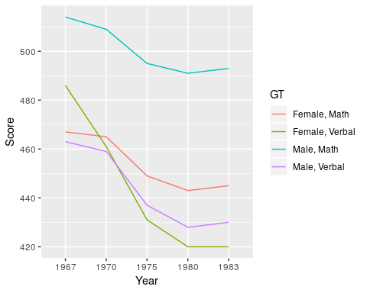
SAT.narrow %>% ggplot( aes( x=factor(Year), y=Score, fill=factor(GT) ) ) +
geom_col()
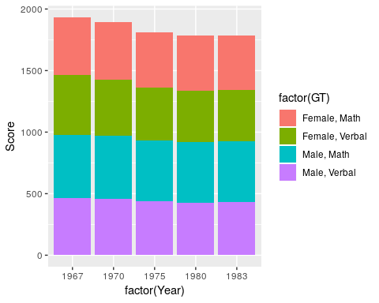
SAT.narrow %>% ggplot( aes( x=factor(Year), y=Score, fill=factor(GT) ) ) +
geom_col(position = "dodge")
