Data Visualization R
Prof. Eric A. Suess
Some of the code from Chapter 3, Section 1.
In this chapter ggplot2 is introduced. We will discuss ggplot2 more in Stat. 651.
The main idea of making graphs with ggplot2 is the idea of mappings that are applied as asthetics in a plot.
The ggplot2 package is part of the tidyverse. We will install and load the tidyverse.
library(mdsr)
library(tidyverse)
CIACountries
## country pop area
## 1 Afghanistan 32564342 652230
## 2 Albania 3029278 28748
## 3 Algeria 39542166 2381741
## 4 American Samoa 54343 199
## 5 Andorra 85580 468
## 6 Angola 19625353 1246700
## 7 Anguilla 16418 91
## 8 Antigua and Barbuda 92436 443
## 9 Argentina 43431886 2780400
## 10 Armenia 3056382 29743
## 11 Aruba 112162 180
## 12 Australia 22751014 7741220
## 13 Austria 8665550 83871
## 14 Azerbaijan 9780780 86600
## 15 Bahamas, The 324597 13880
## 16 Bahrain 1346613 760
## 17 Bangladesh 168957745 143998
## 18 Barbados 290604 430
## 19 Belarus 9589689 207600
## 20 Belgium 11323973 30528
## 21 Belize 347369 22966
## 22 Benin 10448647 112622
## 23 Bermuda 70196 54
## 24 Bhutan 741919 38394
## 25 Bolivia 10800882 1098581
## 26 Bosnia and Herzegovina 3867055 51197
## 27 Botswana 2182719 581730
## 28 Brazil 204259812 8514877
## 29 British Virgin Islands 33454 151
## 30 Brunei 429646 5765
## 31 Bulgaria 7186893 110879
## 32 Burkina Faso 18931686 274200
## 33 Burma 56320206 676578
## 34 Burundi 10742276 27830
## 35 Cabo Verde 545993 4033
## 36 Cambodia 15708756 181035
## 37 Cameroon 23739218 475440
## 38 Canada 35099836 9984670
## 39 Cayman Islands 56092 264
## 40 Central African Republic 5391539 622984
## 41 Chad 11631456 1284000
## 42 Chile 17508260 756102
## 43 China 1367485388 9596960
## 44 Christmas Island 1530 135
## 45 Cocos (Keeling) Islands 596 14
## 46 Colombia 46736728 1138910
## 47 Comoros 780971 2235
## 48 Congo, Democratic Republic of the 79375136 2344858
## 49 Congo, Republic of the 4755097 342000
## 50 Cook Islands 9838 236
## 51 Costa Rica 4814144 51100
## 52 Cote d'Ivoire 23295302 322463
## 53 Croatia 4464844 56594
## 54 Cuba 11031433 110860
## 55 Curacao 146836 444
## 56 Cyprus 1189197 9251
## 57 Czechia 10644842 78867
## 58 Denmark 5581503 43094
## 59 Djibouti 828324 23200
## 60 Dominica 73607 751
## 61 Dominican Republic 10478756 48670
## 62 Ecuador 15868396 283561
## 63 Egypt 88487396 1001450
## 64 El Salvador 6141350 21041
## 65 Equatorial Guinea 740743 28051
## 66 Eritrea 6527689 117600
## 67 Estonia 1265420 45228
## 68 Ethiopia 99465819 1104300
## 69 Falkland Islands (Islas Malvinas) 3361 12173
## 70 Faroe Islands 50196 1393
## 71 Fiji 909389 18274
## 72 Finland 5476922 338145
## 73 France 66553766 643801
## 74 French Polynesia 282703 4167
## 75 Gabon 1705336 267667
## 76 Gambia, The 1967709 11295
## 77 Gaza Strip 1869055 360
## 78 Georgia 4931226 69700
## 79 Germany 80854408 357022
## 80 Ghana 26327649 238533
## 81 Gibraltar 29258 7
## 82 Greece 10775643 131957
## 83 Greenland 57733 2166086
## 84 Grenada 110694 344
## 85 Guam 161785 544
## 86 Guatemala 14918999 108889
## 87 Guernsey 66080 78
## 88 Guinea 11780162 245857
## 89 Guinea-Bissau 1726170 36125
## 90 Guyana 735222 214969
## 91 Haiti 10110019 27750
## 92 Holy See (Vatican City) 842 0
## 93 Honduras 8746673 112090
## 94 Hong Kong 7141106 1108
## 95 Hungary 9897541 93028
## 96 Iceland 331918 103000
## 97 India 1251695584 3287263
## 98 Indonesia 255993674 1904569
## 99 Iran 81824270 1648195
## 100 Iraq 37056169 438317
## 101 Ireland 4892305 70273
## 102 Isle of Man 87545 572
## 103 Israel 8049314 20770
## 104 Italy 61855120 301340
## 105 Jamaica 2950210 10991
## 106 Japan 126919659 377915
## 107 Jersey 97294 116
## 108 Jordan 8117564 89342
## 109 Kazakhstan 18157122 2724900
## 110 Kenya 45925301 580367
## 111 Kiribati 105711 811
## 112 Korea, North 24983205 120538
## 113 Korea, South 49115196 99720
## 114 Kosovo 1870981 10887
## 115 Kuwait 2788534 17818
## 116 Kyrgyzstan 5664939 199951
## 117 Laos 6911544 236800
## 118 Latvia 1986705 64589
## 119 Lebanon 6184701 10400
## 120 Lesotho 1947701 30355
## 121 Liberia 4195666 111369
## 122 Libya 6411776 1759540
## 123 Liechtenstein 37624 160
## 124 Lithuania 2884433 65300
## 125 Luxembourg 570252 2586
## 126 Macau 592731 28
## 127 Macedonia 2096015 25713
## 128 Madagascar 23812681 587041
## 129 Malawi 17964697 118484
## 130 Malaysia 30513848 329847
## 131 Maldives 393253 298
## 132 Mali 16955536 1240192
## 133 Malta 413965 316
## 134 Marshall Islands 72191 181
## 135 Mauritania 3596702 1030700
## 136 Mauritius 1339827 2040
## 137 Mexico 121736809 1964375
## 138 Micronesia, Federated States of 105216 702
## 139 Moldova 3546847 33851
## 140 Monaco 30535 2
## 141 Mongolia 2992908 1564116
## 142 Montenegro 647073 13812
## 143 Montserrat 5241 102
## 144 Morocco 33322699 446550
## 145 Mozambique 25303113 799380
## 146 Namibia 2212307 824292
## 147 Nauru 9540 21
## 148 Nepal 31551305 147181
## 149 Netherlands 16947904 41543
## 150 New Caledonia 271615 18575
## 151 New Zealand 4438393 267710
## 152 Nicaragua 5907881 130370
## 153 Niger 18045729 1267000
## 154 Nigeria 181562056 923768
## 155 Niue 1190 260
## 156 Norfolk Island 2210 36
## 157 Northern Mariana Islands 52344 464
## 158 Norway 5207689 323802
## 159 Oman 3286936 309500
## 160 Pakistan 199085847 796095
## 161 Palau 21265 459
## 162 Panama 3657024 75420
## 163 Papua New Guinea 6672429 462840
## 164 Paraguay 6783272 406752
## 165 Peru 30444999 1285216
## 166 Philippines 100998376 300000
## 167 Pitcairn Islands 48 47
## 168 Poland 38562189 312685
## 169 Portugal 10825309 92090
## 170 Puerto Rico 3598357 13790
## 171 Qatar 2194817 11586
## 172 Romania 21666350 238391
## 173 Russia 142423773 17098242
## 174 Rwanda 12661733 26338
## 175 Saint Helena, Ascension, and Tristan da Cunha 7795 308
## 176 Saint Kitts and Nevis 51936 261
## 177 Saint Lucia 163922 616
## 178 Saint Martin 31754 54
## 179 Saint Pierre and Miquelon 5657 242
## 180 Saint Vincent and the Grenadines 102627 389
## 181 Samoa 197773 2831
## 182 San Marino 33020 61
## 183 Sao Tome and Principe 194006 964
## 184 Saudi Arabia 27752316 2149690
## 185 Senegal 13975834 196722
## 186 Serbia 7176794 77474
## 187 Seychelles 92430 455
## 188 Sierra Leone 5879098 71740
## 189 Singapore 5674472 697
## 190 Sint Maarten 39689 34
## 191 Slovakia 5445027 49035
## 192 Slovenia 1983412 20273
## 193 Solomon Islands 622469 28896
## 194 Somalia 10616380 637657
## 195 South Africa 53675563 1219090
## 196 South Sudan 12042910 644329
## 197 Spain 48146134 505370
## 198 Sri Lanka 22053488 65610
## 199 Sudan 36108853 1861484
## 200 Suriname 579633 163820
## 201 Svalbard 1872 62045
## 202 Swaziland 1435613 17364
## 203 Sweden 9801616 450295
## 204 Switzerland 8121830 41277
## 205 Syria 17064854 185180
## 206 Taiwan 23415126 35980
## 207 Tajikistan 8191958 143100
## 208 Tanzania 51045882 947300
## 209 Thailand 67976405 513120
## 210 Timor-Leste 1231116 14874
## 211 Togo 7552318 56785
## 212 Tokelau 1337 12
## 213 Tonga 106501 747
## 214 Trinidad and Tobago 1222363 5128
## 215 Tunisia 11037225 163610
## 216 Turkey 79414269 783562
## 217 Turkmenistan 5231422 488100
## 218 Turks and Caicos Islands 50280 948
## 219 Tuvalu 10869 26
## 220 Uganda 37101745 241038
## 221 Ukraine 44429471 603550
## 222 United Arab Emirates 5779760 83600
## 223 United Kingdom 64088222 243610
## 224 United States 321368864 9826675
## 225 Uruguay 3341893 176215
## 226 Uzbekistan 29199942 447400
## 227 Vanuatu 272264 12189
## 228 Venezuela 29275460 912050
## 229 Vietnam 94348835 331210
## 230 Virgin Islands 103574 1910
## 231 Wallis and Futuna 15613 142
## 232 West Bank 2785366 5860
## 233 Western Sahara 570866 266000
## 234 Yemen 26737317 527968
## 235 Zambia 15066266 752618
## 236 Zimbabwe 14229541 390757
## oil_prod gdp educ roadways net_users
## 1 0 1900 NA 0.064624442 >5%
## 2 20510 11900 3.3 0.626130513 >35%
## 3 1420000 14500 4.3 0.047719294 >15%
## 4 0 13000 NA 1.211055276 <NA>
## 5 NA 37200 NA 0.683760684 >60%
## 6 1742000 7300 3.5 0.041252106 >15%
## 7 NA 12200 2.8 1.923076923 >15%
## 8 0 23600 2.4 2.641083521 >60%
## 9 532100 22600 6.3 0.083216084 >35%
## 10 0 8500 3.3 0.259052550 >35%
## 11 0 25300 6.0 NA >60%
## 12 354300 65400 5.6 0.106342024 >60%
## 13 21760 47300 5.9 1.484517891 >60%
## 14 845900 18000 2.4 0.611339492 >35%
## 15 0 25200 NA 0.194524496 >60%
## 16 49500 50100 2.6 5.423684211 >60%
## 17 4000 3600 2.2 0.147703440 >5%
## 18 1000 16600 5.6 3.720930233 >60%
## 19 30000 17700 5.1 0.416146435 >35%
## 20 0 43600 6.6 5.044942348 >60%
## 21 1818 8400 6.6 0.124967343 >15%
## 22 0 2100 5.3 0.142068157 >0%
## 23 0 85700 2.6 8.277777778 >60%
## 24 0 8200 4.7 0.275511799 >15%
## 25 51130 6500 6.9 0.073265421 >35%
## 26 0 10500 NA 0.447799676 >60%
## 27 0 16400 9.5 0.030797793 >5%
## 28 2255000 15600 5.8 0.185670797 >35%
## 29 0 42300 4.4 1.324503311 >5%
## 30 126500 79700 3.5 0.525411969 >60%
## 31 1000 19100 4.1 0.175975613 >35%
## 32 0 1700 3.4 0.055696572 >0%
## 33 20000 5500 0.8 0.050810106 >0%
## 34 0 800 5.8 0.442759612 >0%
## 35 0 6500 5.0 0.334738408 >35%
## 36 0 3500 2.6 0.218841660 >5%
## 37 80830 3100 3.2 0.108005216 >5%
## 38 3890000 45600 5.4 0.104390030 >60%
## 39 0 43800 NA 2.973484848 >60%
## 40 0 600 1.2 0.032549793 >0%
## 41 103400 2600 2.3 0.031152648 >0%
## 42 6666 23500 4.5 0.102848557 >60%
## 43 4189000 14100 NA 0.427884142 >35%
## 44 NA NA NA 1.037037037 >15%
## 45 NA NA NA 1.571428571 <NA>
## 46 989900 13800 4.4 0.124130967 >35%
## 47 0 1500 7.6 0.393736018 >5%
## 48 20000 800 2.5 0.065461107 >0%
## 49 250000 6700 6.2 0.050552632 >0%
## 50 0 12300 3.1 1.355932203 >5%
## 51 0 15500 6.3 0.763561644 >35%
## 52 36000 3300 4.6 0.254280336 >0%
## 53 10070 21600 4.3 0.519666396 >60%
## 54 50000 10200 12.8 0.548962656 >15%
## 55 NA 15000 NA 1.238738739 <NA>
## 56 0 32800 7.3 2.162577019 >60%
## 57 3000 31600 4.2 1.656852676 >60%
## 58 165200 45700 8.7 1.715528844 >60%
## 59 0 3200 8.4 0.132112069 >5%
## 60 0 10700 3.5 2.013315579 >35%
## 61 0 15000 2.2 0.404869529 >35%
## 62 556400 11300 4.4 0.154005664 >35%
## 63 478400 11800 3.8 0.137231015 >35%
## 64 0 8300 3.4 0.328786655 >15%
## 65 248000 31800 0.6 0.102670137 >15%
## 66 0 1300 2.1 0.034098639 >0%
## 67 0 28600 5.7 1.291500840 >60%
## 68 0 1800 4.7 0.040169338 >0%
## 69 0 55400 NA 0.036145568 >60%
## 70 0 36600 NA 0.332376167 >60%
## 71 0 9000 4.2 0.188245595 >35%
## 72 0 41100 6.8 0.230670275 >60%
## 73 15340 41200 5.9 1.597459463 >60%
## 74 0 26100 NA 0.621550276 >35%
## 75 240000 18600 NA 0.034258986 >5%
## 76 0 1600 4.1 0.331119965 >5%
## 77 NA NA NA NA <NA>
## 78 1000 9600 2.0 0.274160689 >35%
## 79 48830 46900 5.1 1.806611357 >60%
## 80 105000 4300 8.1 0.459118864 >15%
## 81 0 43000 NA 4.142857143 >60%
## 82 1162 26400 4.1 0.886349341 >35%
## 83 0 37900 NA NA >60%
## 84 0 13100 3.9 3.276162791 >35%
## 85 0 30500 NA 1.920955882 >60%
## 86 10040 7700 3.0 0.105621321 >15%
## 87 NA 52300 NA NA >60%
## 88 0 1200 2.5 0.180381279 >0%
## 89 0 1500 NA 0.095640138 >0%
## 90 0 7500 3.2 0.037075113 >35%
## 91 0 1800 NA 0.153729730 >5%
## 92 NA NA NA NA <NA>
## 93 0 4900 NA 0.131519315 >15%
## 94 0 56700 3.5 1.886281588 >60%
## 95 11410 26200 4.9 2.145235843 >60%
## 96 0 46100 7.6 0.125145631 >60%
## 97 767600 6200 3.2 1.426670759 >15%
## 98 789800 11100 2.8 0.260745082 >15%
## 99 3614000 17300 3.7 0.120656840 >15%
## 100 3368000 15500 NA 0.136027122 >5%
## 101 0 55500 6.4 1.366613066 >60%
## 102 NA 83100 NA 0.874125874 <NA>
## 103 390 33700 5.6 0.893885412 >60%
## 104 105700 35700 4.5 1.618437645 >35%
## 105 0 8800 6.1 2.012646711 >35%
## 106 4666 38100 3.8 3.202442348 >60%
## 107 NA 57000 NA 4.965517241 >15%
## 108 22 12100 NA 0.080622775 >35%
## 109 1632000 24300 3.1 0.035751037 >35%
## 110 0 3200 6.7 0.277200461 >35%
## 111 0 1800 12.0 0.826140567 >5%
## 112 0 1800 NA 0.211999535 <NA>
## 113 0 36500 5.0 1.052777778 >60%
## 114 NA NA 4.3 0.638835308 <NA>
## 115 2619000 70200 3.8 0.370860927 >60%
## 116 1000 3400 6.8 0.170041660 >15%
## 117 0 5300 2.8 0.167094595 >0%
## 118 0 24700 5.0 1.121553206 >60%
## 119 0 18200 2.2 0.670192308 >60%
## 120 0 3000 13.0 0.195684401 >5%
## 121 0 900 2.8 0.095179089 >0%
## 122 470000 14600 NA 0.056846676 >15%
## 123 NA 89400 2.1 2.375000000 >60%
## 124 2000 28400 5.4 1.288912711 >60%
## 125 0 99000 3.7 1.121036350 >60%
## 126 0 98200 2.7 14.750000000 >35%
## 127 0 14000 NA 0.545949520 >35%
## 128 0 1500 2.7 0.058728436 >60%
## 129 0 1100 5.4 0.130397353 >0%
## 130 597500 26300 5.9 0.437787823 >35%
## 131 0 14900 6.8 0.295302013 >0%
## 132 0 2200 4.8 0.018121388 >60%
## 133 0 35900 6.9 9.797468354 >35%
## 134 NA 3200 12.2 11.204419890 >0%
## 135 6003 4400 3.7 0.010311439 >5%
## 136 0 19500 3.5 1.053431373 >5%
## 137 2459000 17500 5.1 0.192254534 >35%
## 138 0 3000 NA 0.341880342 >15%
## 139 0 5000 8.4 0.276269534 >35%
## 140 NA 78700 1.6 38.500000000 >60%
## 141 20850 12100 5.5 0.031486795 >15%
## 142 0 16100 NA 0.562047495 >35%
## 143 0 8500 NA NA >15%
## 144 500 8200 5.4 0.130769231 >35%
## 145 0 1200 5.0 0.037943156 >5%
## 146 0 11400 8.4 0.053546559 >5%
## 147 0 14800 NA 1.428571429 <NA>
## 148 0 2500 4.7 0.073677988 >5%
## 149 28120 49200 5.9 3.353031798 >60%
## 150 0 38800 NA 0.302664872 >60%
## 151 39860 36200 7.4 0.351723880 >60%
## 152 0 5000 4.6 0.183301373 >5%
## 153 20000 1100 4.2 0.014955801 >0%
## 154 2423000 6100 NA 0.209143421 >35%
## 155 0 5800 NA 0.461538462 >60%
## 156 NA NA NA 2.222222222 <NA>
## 157 NA 13300 NA 1.155172414 <NA>
## 158 1568000 68400 6.9 0.289899383 >60%
## 159 943500 44600 4.3 0.194636511 >60%
## 160 98000 5000 2.1 0.329428021 >5%
## 161 NA 15100 7.3 NA <NA>
## 162 0 21800 3.5 0.200702731 >35%
## 163 34210 2700 NA 0.020199205 >0%
## 164 0 8700 4.8 0.078817068 >15%
## 165 69300 12200 2.8 0.109453975 >35%
## 166 21000 7300 2.7 0.710503333 >35%
## 167 NA NA NA NA <NA>
## 168 19260 26500 5.2 1.317731903 >60%
## 169 0 27800 5.6 0.900206320 >60%
## 170 0 38000 NA 1.947933285 >35%
## 171 1540000 132100 2.5 0.848437770 >60%
## 172 83350 20800 4.2 0.353138332 >35%
## 173 10840000 25400 4.1 0.075059588 >35%
## 174 0 1800 5.1 0.178449389 >5%
## 175 0 7800 NA 0.642857143 >5%
## 176 0 24600 4.2 1.467432950 >15%
## 177 0 11700 4.1 1.964285714 >60%
## 178 NA 19300 NA NA <NA>
## 179 0 34900 NA 0.483471074 <NA>
## 180 0 11000 5.1 2.131105398 >60%
## 181 0 5200 5.8 0.825503356 >5%
## 182 NA 63900 NA 4.786885246 >35%
## 183 0 3200 9.5 0.331950207 >15%
## 184 9735000 53600 5.1 0.102978569 >35%
## 185 0 2500 5.6 0.071207084 >15%
## 186 16840 13700 4.8 0.571133542 >35%
## 187 0 26300 3.6 1.116483516 >35%
## 188 0 1600 2.9 0.157513242 >0%
## 189 0 85300 3.0 4.913916786 >60%
## 190 NA 66800 NA 1.558823529 <NA>
## 191 200 29700 4.2 0.895605180 >60%
## 192 5 31000 5.7 1.923001036 >60%
## 193 0 1900 7.3 0.048103544 >5%
## 194 0 400 NA 0.034658131 >0%
## 195 3000 13200 6.0 0.612763619 >35%
## 196 220000 2000 NA 0.010864015 <NA>
## 197 6419 34800 5.0 1.351831331 >60%
## 198 0 10600 1.7 1.738957476 >15%
## 199 64770 4300 NA 0.006392749 >15%
## 200 15000 16300 NA 0.026272738 >35%
## 201 194300 NA NA NA <NA>
## 202 0 8500 8.3 0.206979959 >15%
## 203 0 47900 7.0 1.287076250 >60%
## 204 0 58600 5.2 1.731327374 >60%
## 205 22660 5100 5.1 0.377324765 >15%
## 206 159 46800 NA 1.152723735 >60%
## 207 206 2700 3.9 0.194039133 >15%
## 208 0 2900 6.2 0.091282593 >5%
## 209 232900 16100 5.8 0.350898425 >15%
## 210 76490 5600 9.4 0.406077720 >0%
## 211 0 1500 4.5 0.205195034 >0%
## 212 NA 1000 NA NA >35%
## 213 0 5100 3.9 0.910307898 >35%
## 214 81260 32600 3.2 1.622464899 >60%
## 215 55050 11400 6.2 0.118684677 >35%
## 216 47670 20400 2.9 0.492300545 >35%
## 217 242900 16400 NA 0.120040975 >5%
## 218 0 29100 NA 0.127637131 <NA>
## 219 0 3400 NA 0.307692308 >35%
## 220 0 2000 3.3 0.082974469 >15%
## 221 40490 7500 6.2 0.281159804 >35%
## 222 2820000 67600 NA 0.048803828 >60%
## 223 787200 41200 6.2 1.619096096 >60%
## 224 8653000 55800 5.4 0.670278604 >60%
## 225 0 21500 4.5 0.441120222 >35%
## 226 64810 6100 NA 0.193330353 >35%
## 227 0 2500 5.0 0.087784068 >5%
## 228 2500000 16700 6.9 0.105427334 >35%
## 229 298400 6000 6.3 0.623873071 >35%
## 230 0 36100 NA 0.659685864 >15%
## 231 NA 3800 NA NA >5%
## 232 0 4300 NA 0.799658703 >35%
## 233 0 2500 NA NA <NA>
## 234 125100 2700 5.2 0.135046063 >15%
## 235 0 3900 1.3 0.053751040 >15%
## 236 0 2100 2.5 0.248919405 >15%

Aesthetics
g <- ggplot(data = CIACountries, aes(y = gdp, x = educ))
g + geom_point(size = 3)
## Warning: Removed 64 rows containing missing values (geom_point).
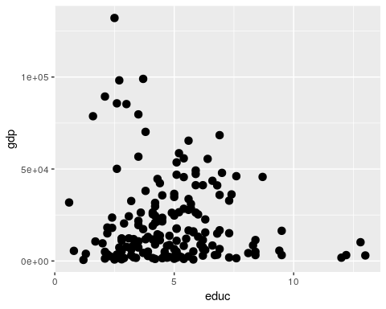
g + geom_point(aes(color = net_users), size = 3)
## Warning: Removed 64 rows containing missing values (geom_point).
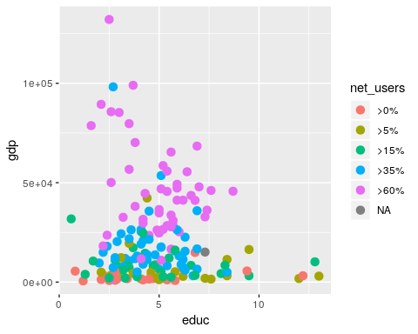
g <- ggplot(data = CIACountries, aes(y = gdp, x = educ, label = country, color = net_users))
g + geom_text(size = 3)
## Warning: Removed 64 rows containing missing values (geom_text).
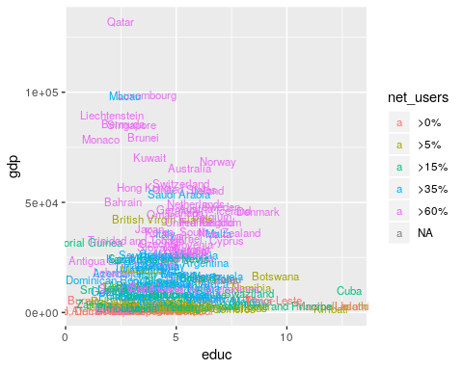

Scale
g <- ggplot(data = CIACountries, aes(y = gdp, x = educ))
g + geom_point(size = 3)
## Warning: Removed 64 rows containing missing values (geom_point).
g + geom_point(aes(color = net_users, size = roadways))
## Warning: Removed 66 rows containing missing values (geom_point).
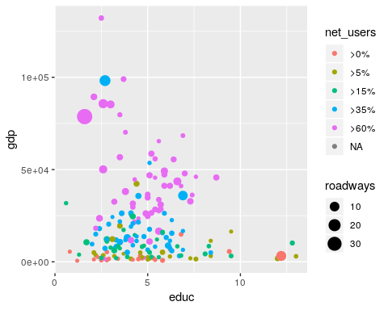
g + geom_point(aes(color = net_users, size = roadways)) +
coord_trans(y = "log10")
## Warning: Removed 66 rows containing missing values (geom_point).
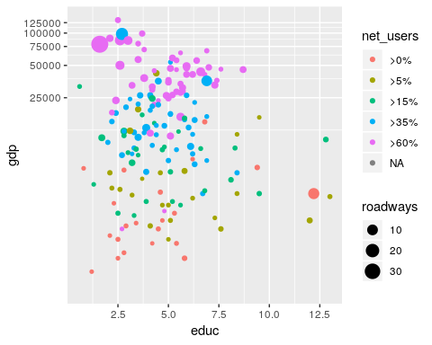

Facets
g + geom_point(alpha = 0.9, aes(size = roadways)) +
coord_trans(y = "log10") +
facet_wrap( ~ net_users, nrow = 1) +
theme(legend.position = "top")
## Warning: Removed 66 rows containing missing values (geom_point).
