Quiz 2 preparation solution
Answer the following questions.
These questions relate to the homework problem 12.2.1 Exercise 2. Use what you know from Chapter 13 to answer the questions for table4a and table4b.
- Using table4a and table4b from the tidyverse R package, merge the two dataframes into one and create a column, rate per 10000 variable, for each year.
library(tidyverse)
table4a
## # A tibble: 3 x 3
## country `1999` `2000`
## * <chr> <int> <int>
## 1 Afghanistan 745 2666
## 2 Brazil 37737 80488
## 3 China 212258 213766
table4b
## # A tibble: 3 x 3
## country `1999` `2000`
## * <chr> <int> <int>
## 1 Afghanistan 19987071 20595360
## 2 Brazil 172006362 174504898
## 3 China 1272915272 1280428583
table_new2 <- table4a %>% inner_join(table4b, by = c("country"))
table_new2
## # A tibble: 3 x 5
## country `1999.x` `2000.x` `1999.y` `2000.y`
## <chr> <int> <int> <int> <int>
## 1 Afghanistan 745 2666 19987071 20595360
## 2 Brazil 37737 80488 172006362 174504898
## 3 China 212258 213766 1272915272 1280428583
table_new2a <- table_new2 %>% mutate(
rate.1999 = (`1999.x`/`1999.y`)*10000,
rate.2000 = (`2000.x`/`2000.y`)*10000
) %>%
select(country, rate.1999, rate.2000)
table_new2a
## # A tibble: 3 x 3
## country rate.1999 rate.2000
## <chr> <dbl> <dbl>
## 1 Afghanistan 0.373 1.29
## 2 Brazil 2.19 4.61
## 3 China 1.67 1.67
- Is your final dataframe for questions 1 tidy? Yes or no, explain.
Answer: No. The table_new2a is not tidy. The rates are in two columns.
- Convert your final dataframe for question 1 into a tidy dataframe with three columns country, year and rate.
Answer: Gather the columns into year and rate columns.
table_new2a %>% gather(rate.1999, rate.2000, key = "year", value = "rate")
## # A tibble: 6 x 3
## country year rate
## <chr> <chr> <dbl>
## 1 Afghanistan rate.1999 0.373
## 2 Brazil rate.1999 2.19
## 3 China rate.1999 1.67
## 4 Afghanistan rate.2000 1.29
## 5 Brazil rate.2000 4.61
## 6 China rate.2000 1.67
- Make a clustered bar graph displaying the data.
Note the use of the as.factor() function.
table_new2a %>% gather(rate.1999, rate.2000, key = "year", value = "rate") %>%
ggplot(aes(x = as.factor(year), y = rate, fill = country) ) +
geom_bar(position="dodge", stat="identity")
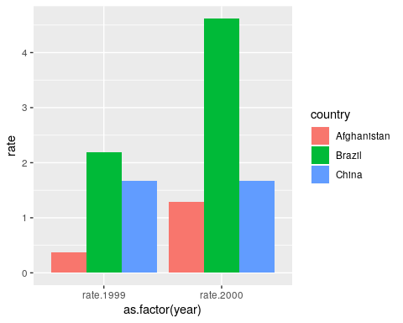
The next question relates to Chapter 14.
library(stringr)
- For the string “Today is the second quiz.”
  - Use an str_? R function to count the length of the string.
  - Use an str_ R function to change all of the letters to lower case.
  - Use an str_? R function to subset the string into separate words.
x <- "Today is the second quiz."
x
## [1] "Today is the second quiz."
# a.
str_count(x)
## [1] 25
# b.
str_to_lower(x)
## [1] "today is the second quiz."
# c.
str_split(x, " ")
## [[1]]
## [1] "Today" "is" "the" "second" "quiz."

