Stat 450 Dates and Times
Prof. Eric A. Suess
December 3, 2018

Chapter 16 Dates and Times
library(tidyverse)
## ── Attaching packages ──────────────────────────────────────────────────────────────────────────────────────────── tidyverse 1.2.1 ──
## ✔ ggplot2 3.1.0 ✔ purrr 0.2.5
## ✔ tibble 1.4.2 ✔ dplyr 0.7.7
## ✔ tidyr 0.8.2 ✔ stringr 1.3.1
## ✔ readr 1.1.1 ✔ forcats 0.3.0
## ── Conflicts ─────────────────────────────────────────────────────────────────────────────────────────────── tidyverse_conflicts() ──
## ✖ dplyr::filter() masks stats::filter()
## ✖ dplyr::lag() masks stats::lag()
library(lubridate)
##
## Attaching package: 'lubridate'
## The following object is masked from 'package:base':
##
## date
library(nycflights13)
today()
## [1] "2018-12-03"
now()
## [1] "2018-12-03 10:31:25 PST"
Dates from strings
ymd("2017-01-31")
## [1] "2017-01-31"
mdy("January 31st, 2017")
## [1] "2017-01-31"
dmy("31-Jan-2017")
## [1] "2017-01-31"
Dates with times
ymd_hms("2017-01-31 20:11:59")
## [1] "2017-01-31 20:11:59 UTC"
mdy_hm("01/31/2017 08:01")
## [1] "2017-01-31 08:01:00 UTC"
flights %>%
select(year, month, day, hour, minute)
## # A tibble: 336,776 x 5
## year month day hour minute
## <int> <int> <int> <dbl> <dbl>
## 1 2013 1 1 5 15
## 2 2013 1 1 5 29
## 3 2013 1 1 5 40
## 4 2013 1 1 5 45
## 5 2013 1 1 6 0
## 6 2013 1 1 5 58
## 7 2013 1 1 6 0
## 8 2013 1 1 6 0
## 9 2013 1 1 6 0
## 10 2013 1 1 6 0
## # ... with 336,766 more rows
flights %>%
select(year, month, day, hour, minute) %>%
mutate(departure = make_datetime(year, month, day, hour, minute))
## # A tibble: 336,776 x 6
## year month day hour minute departure
## <int> <int> <int> <dbl> <dbl> <dttm>
## 1 2013 1 1 5 15 2013-01-01 05:15:00
## 2 2013 1 1 5 29 2013-01-01 05:29:00
## 3 2013 1 1 5 40 2013-01-01 05:40:00
## 4 2013 1 1 5 45 2013-01-01 05:45:00
## 5 2013 1 1 6 0 2013-01-01 06:00:00
## 6 2013 1 1 5 58 2013-01-01 05:58:00
## 7 2013 1 1 6 0 2013-01-01 06:00:00
## 8 2013 1 1 6 0 2013-01-01 06:00:00
## 9 2013 1 1 6 0 2013-01-01 06:00:00
## 10 2013 1 1 6 0 2013-01-01 06:00:00
## # ... with 336,766 more rows
make_datetime_100 <- function(year, month, day, time) {
make_datetime(year, month, day, time %/% 100, time %% 100)
}
flights_dt <- flights %>%
filter(!is.na(dep_time), !is.na(arr_time)) %>%
mutate(
dep_time = make_datetime_100(year, month, day, dep_time),
arr_time = make_datetime_100(year, month, day, arr_time),
sched_dep_time = make_datetime_100(year, month, day, sched_dep_time),
sched_arr_time = make_datetime_100(year, month, day, sched_arr_time)
) %>%
select(origin, dest, ends_with("delay"), ends_with("time"))
flights_dt
## # A tibble: 328,063 x 9
## origin dest dep_delay arr_delay dep_time sched_dep_time
## <chr> <chr> <dbl> <dbl> <dttm> <dttm>
## 1 EWR IAH 2 11 2013-01-01 05:17:00 2013-01-01 05:15:00
## 2 LGA IAH 4 20 2013-01-01 05:33:00 2013-01-01 05:29:00
## 3 JFK MIA 2 33 2013-01-01 05:42:00 2013-01-01 05:40:00
## 4 JFK BQN -1 -18 2013-01-01 05:44:00 2013-01-01 05:45:00
## 5 LGA ATL -6 -25 2013-01-01 05:54:00 2013-01-01 06:00:00
## 6 EWR ORD -4 12 2013-01-01 05:54:00 2013-01-01 05:58:00
## 7 EWR FLL -5 19 2013-01-01 05:55:00 2013-01-01 06:00:00
## 8 LGA IAD -3 -14 2013-01-01 05:57:00 2013-01-01 06:00:00
## 9 JFK MCO -3 -8 2013-01-01 05:57:00 2013-01-01 06:00:00
## 10 LGA ORD -2 8 2013-01-01 05:58:00 2013-01-01 06:00:00
## # ... with 328,053 more rows, and 3 more variables: arr_time <dttm>,
## # sched_arr_time <dttm>, air_time <dbl>
flights_dt %>%
ggplot(aes(dep_time)) +
geom_freqpoly(binwidth = 86400) # 86400 seconds = 1 day
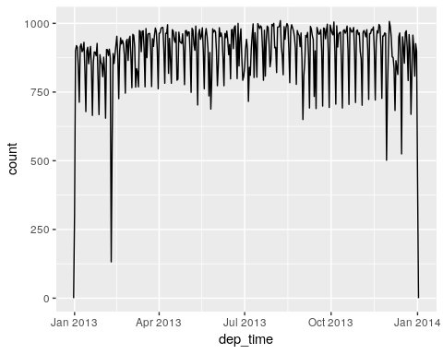
flights_dt %>%
filter(dep_time < ymd(20130102)) %>%
ggplot(aes(dep_time)) +
geom_freqpoly(binwidth = 600) # 600 s = 10 minutes
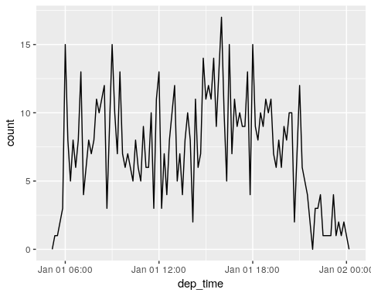
Getting the components
datetime <- ymd_hms("2016-07-08 12:34:56")
year(datetime)
## [1] 2016
month(datetime)
## [1] 7
mday(datetime)
## [1] 8
yday(datetime)
## [1] 190
wday(datetime)
## [1] 6
flights_dt %>%
mutate(wday = wday(dep_time, label = TRUE)) %>%
ggplot(aes(x = wday)) +
geom_bar()
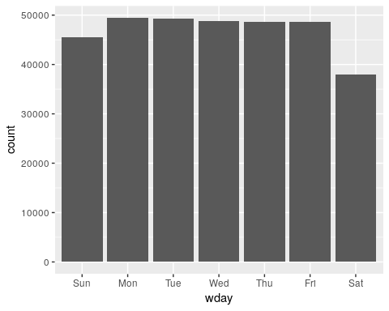
flights_dt %>%
mutate(minute = minute(dep_time)) %>%
group_by(minute) %>%
summarise(
avg_delay = mean(arr_delay, na.rm = TRUE),
n = n()) %>%
ggplot(aes(minute, avg_delay)) +
geom_line()
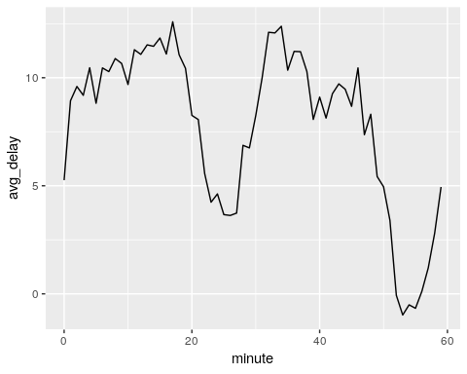
sched_dep <- flights_dt %>%
mutate(minute = minute(sched_dep_time)) %>%
group_by(minute) %>%
summarise(
avg_delay = mean(arr_delay, na.rm = TRUE),
n = n())
ggplot(sched_dep, aes(minute, avg_delay)) +
geom_line()
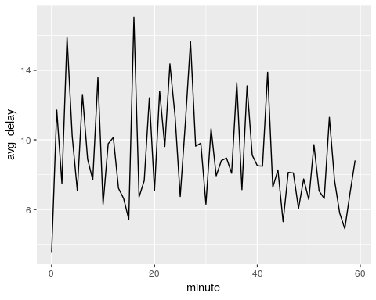
Time zones
Sys.timezone()
## [1] "America/Los_Angeles"
All of the time zones
length(OlsonNames())
## [1] 606
head(OlsonNames())
## [1] "Africa/Abidjan" "Africa/Accra" "Africa/Addis_Ababa"
## [4] "Africa/Algiers" "Africa/Asmara" "Africa/Asmera"
(x1 <- ymd_hms("2015-06-01 12:00:00", tz = "America/New_York"))
## [1] "2015-06-01 12:00:00 EDT"
(x2 <- ymd_hms("2015-06-01 18:00:00", tz = "Europe/Copenhagen"))
## [1] "2015-06-01 18:00:00 CEST"
(x3 <- ymd_hms("2015-06-02 04:00:00", tz = "Pacific/Auckland"))
## [1] "2015-06-02 04:00:00 NZST"

