Basic Statistics and Hypothesis Testing in R
Prof. Eric A. Suess
November 28, 2018
If you want to learn about Statistics using base R a nice website is the Quick-R website, see Statistics > t-tests
These are some example of basic statistics and hypothesis testing in R. Most of the code here is from base R.
We will use the mtcars data set.
library(tidyverse)
## ── Attaching packages ───────────────────────────────────────────────────────────────────────────── tidyverse 1.2.1 ──
## ✔ ggplot2 3.2.1 ✔ purrr 0.3.2
## ✔ tibble 2.1.3 ✔ dplyr 0.8.3
## ✔ tidyr 1.0.0 ✔ stringr 1.4.0
## ✔ readr 1.3.1 ✔ forcats 0.4.0
## ── Conflicts ──────────────────────────────────────────────────────────────────────────────── tidyverse_conflicts() ──
## ✖ dplyr::filter() masks stats::filter()
## ✖ dplyr::lag() masks stats::lag()
mtcars
## mpg cyl disp hp drat wt qsec vs am gear carb
## Mazda RX4 21.0 6 160.0 110 3.90 2.620 16.46 0 1 4 4
## Mazda RX4 Wag 21.0 6 160.0 110 3.90 2.875 17.02 0 1 4 4
## Datsun 710 22.8 4 108.0 93 3.85 2.320 18.61 1 1 4 1
## Hornet 4 Drive 21.4 6 258.0 110 3.08 3.215 19.44 1 0 3 1
## Hornet Sportabout 18.7 8 360.0 175 3.15 3.440 17.02 0 0 3 2
## Valiant 18.1 6 225.0 105 2.76 3.460 20.22 1 0 3 1
## Duster 360 14.3 8 360.0 245 3.21 3.570 15.84 0 0 3 4
## Merc 240D 24.4 4 146.7 62 3.69 3.190 20.00 1 0 4 2
## Merc 230 22.8 4 140.8 95 3.92 3.150 22.90 1 0 4 2
## Merc 280 19.2 6 167.6 123 3.92 3.440 18.30 1 0 4 4
## Merc 280C 17.8 6 167.6 123 3.92 3.440 18.90 1 0 4 4
## Merc 450SE 16.4 8 275.8 180 3.07 4.070 17.40 0 0 3 3
## Merc 450SL 17.3 8 275.8 180 3.07 3.730 17.60 0 0 3 3
## Merc 450SLC 15.2 8 275.8 180 3.07 3.780 18.00 0 0 3 3
## Cadillac Fleetwood 10.4 8 472.0 205 2.93 5.250 17.98 0 0 3 4
## Lincoln Continental 10.4 8 460.0 215 3.00 5.424 17.82 0 0 3 4
## Chrysler Imperial 14.7 8 440.0 230 3.23 5.345 17.42 0 0 3 4
## Fiat 128 32.4 4 78.7 66 4.08 2.200 19.47 1 1 4 1
## Honda Civic 30.4 4 75.7 52 4.93 1.615 18.52 1 1 4 2
## Toyota Corolla 33.9 4 71.1 65 4.22 1.835 19.90 1 1 4 1
## Toyota Corona 21.5 4 120.1 97 3.70 2.465 20.01 1 0 3 1
## Dodge Challenger 15.5 8 318.0 150 2.76 3.520 16.87 0 0 3 2
## AMC Javelin 15.2 8 304.0 150 3.15 3.435 17.30 0 0 3 2
## Camaro Z28 13.3 8 350.0 245 3.73 3.840 15.41 0 0 3 4
## Pontiac Firebird 19.2 8 400.0 175 3.08 3.845 17.05 0 0 3 2
## Fiat X1-9 27.3 4 79.0 66 4.08 1.935 18.90 1 1 4 1
## Porsche 914-2 26.0 4 120.3 91 4.43 2.140 16.70 0 1 5 2
## Lotus Europa 30.4 4 95.1 113 3.77 1.513 16.90 1 1 5 2
## Ford Pantera L 15.8 8 351.0 264 4.22 3.170 14.50 0 1 5 4
## Ferrari Dino 19.7 6 145.0 175 3.62 2.770 15.50 0 1 5 6
## Maserati Bora 15.0 8 301.0 335 3.54 3.570 14.60 0 1 5 8
## Volvo 142E 21.4 4 121.0 109 4.11 2.780 18.60 1 1 4 2

Summary Statistics
mtcars %>% summarize(mpg_mean = mean(mpg), mpg_sd = sd(mpg))
## mpg_mean mpg_sd
## 1 20.09062 6.026948

Subsets and statistics.
mtcars %>% group_by(vs) %>%
summarize(mpg_mean = mean(mpg), mpg_sd = sd(mpg))
## # A tibble: 2 x 3
## vs mpg_mean mpg_sd
## <dbl> <dbl> <dbl>
## 1 0 16.6 3.86
## 2 1 24.6 5.38
Note that the t.test function does not work well with the tidyverse. There is a new package called infer that works with the tidyverse. And if you are interested chech out the broom package.
I like using the formula interface when doing hypothesis testing.

t test
?t.test
with(mtcars, boxplot(mpg ~ vs))
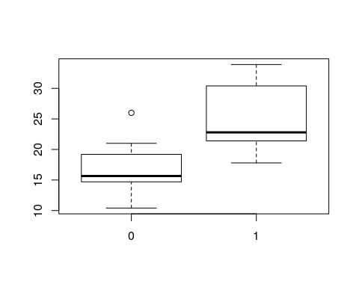
output1 <- with(mtcars, t.test(mpg ~vs))
output1
##
## Welch Two Sample t-test
##
## data: mpg by vs
## t = -4.6671, df = 22.716, p-value = 0.0001098
## alternative hypothesis: true difference in means is not equal to 0
## 95 percent confidence interval:
## -11.462508 -4.418445
## sample estimates:
## mean in group 0 mean in group 1
## 16.61667 24.55714
summary(output1)
## Length Class Mode
## statistic 1 -none- numeric
## parameter 1 -none- numeric
## p.value 1 -none- numeric
## conf.int 2 -none- numeric
## estimate 2 -none- numeric
## null.value 1 -none- numeric
## alternative 1 -none- character
## method 1 -none- character
## data.name 1 -none- character
output1$statistic
## t
## -4.667053
output1$p.value
## [1] 0.0001098368

ANOVA
?aov
with(mtcars, boxplot(mpg ~cyl))
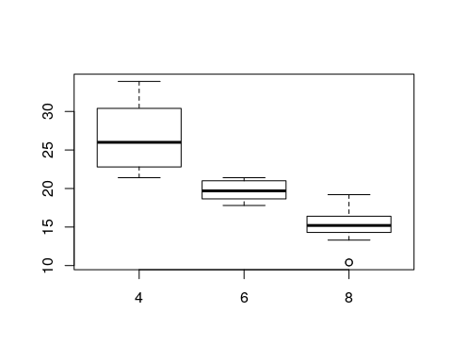
output2 <- with(mtcars, aov(mpg ~ cyl))
output2
## Call:
## aov(formula = mpg ~ cyl)
##
## Terms:
## cyl Residuals
## Sum of Squares 817.7130 308.3342
## Deg. of Freedom 1 30
##
## Residual standard error: 3.205902
## Estimated effects may be unbalanced
summary(output2)
## Df Sum Sq Mean Sq F value Pr(>F)
## cyl 1 817.7 817.7 79.56 6.11e-10 ***
## Residuals 30 308.3 10.3
## ---
## Signif. codes: 0 '***' 0.001 '**' 0.01 '*' 0.05 '.' 0.1 ' ' 1

Linear Regression
?lm
attach(mtcars)
## The following object is masked from package:ggplot2:
##
## mpg
plot(mpg ~ wt)
output3 <-lm(mpg ~ wt)
output3
##
## Call:
## lm(formula = mpg ~ wt)
##
## Coefficients:
## (Intercept) wt
## 37.285 -5.344
summary(output3)
##
## Call:
## lm(formula = mpg ~ wt)
##
## Residuals:
## Min 1Q Median 3Q Max
## -4.5432 -2.3647 -0.1252 1.4096 6.8727
##
## Coefficients:
## Estimate Std. Error t value Pr(>|t|)
## (Intercept) 37.2851 1.8776 19.858 < 2e-16 ***
## wt -5.3445 0.5591 -9.559 1.29e-10 ***
## ---
## Signif. codes: 0 '***' 0.001 '**' 0.01 '*' 0.05 '.' 0.1 ' ' 1
##
## Residual standard error: 3.046 on 30 degrees of freedom
## Multiple R-squared: 0.7528, Adjusted R-squared: 0.7446
## F-statistic: 91.38 on 1 and 30 DF, p-value: 1.294e-10
plot(mpg ~ wt)
abline(lm(mpg ~ wt))
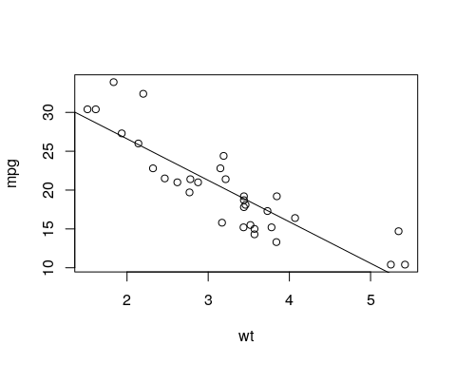
detach(mtcars)

Using ggplot
mtcars %>% ggplot(aes(x = wt, y = mpg)) +
geom_point() +
geom_smooth(method=lm) +
geom_smooth()
## `geom_smooth()` using method = 'loess' and formula 'y ~ x'
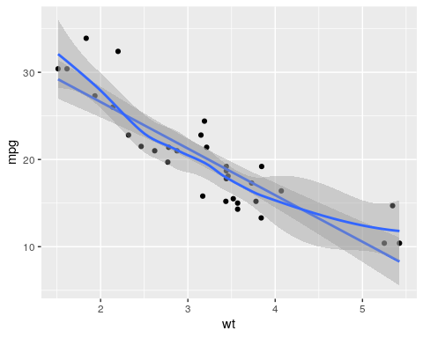
If you want to learn Hypothesis Testing using modern R code check out the book moderndive. See Chapter 10. The authors of this book are working on a new package called infer R package.
library(infer)
The two sample t test example from the website.
library(nycflights13)
library(dplyr)
library(stringr)
library(infer)
set.seed(2017)
fli_small <- flights %>%
sample_n(size = 500) %>%
mutate(half_year = case_when(
between(month, 1, 6) ~ "h1",
between(month, 7, 12) ~ "h2"
)) %>%
mutate(day_hour = case_when(
between(hour, 1, 12) ~ "morning",
between(hour, 13, 24) ~ "not morning"
)) %>%
select(arr_delay, dep_delay, half_year,
day_hour, origin, carrier)
obs_t <- fli_small %>%
specify(arr_delay ~ half_year) %>%
calculate(stat = "t", order = c("h1", "h2"))
## Warning: Removed 15 rows containing missing values.
obs_t <- fli_small %>%
t_stat(formula = arr_delay ~ half_year, order = c("h1", "h2"))
t_null_perm <- fli_small %>%
# alt: response = arr_delay, explanatory = half_year
specify(arr_delay ~ half_year) %>%
hypothesize(null = "independence") %>%
generate(reps = 1000, type = "permute") %>%
calculate(stat = "t", order = c("h1", "h2"))
## Warning: Removed 15 rows containing missing values.
visualize(t_null_perm) +
shade_p_value(obs_stat = obs_t, direction = "two_sided")
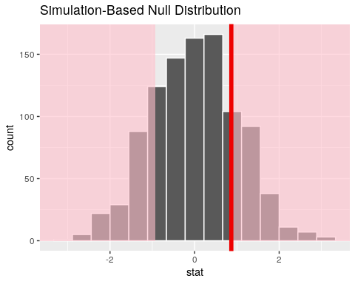
Randomized p-value
t_null_perm %>%
get_p_value(obs_stat = obs_t, direction = "two_sided")
## # A tibble: 1 x 1
## p_value
## <dbl>
## 1 0.408
Theoretical p-value
t_null_theor <- fli_small %>%
# alt: response = arr_delay, explanatory = half_year
specify(arr_delay ~ half_year) %>%
hypothesize(null = "independence") %>%
# generate() ## Not used for theoretical
calculate(stat = "t", order = c("h1", "h2"))
## Warning: Removed 15 rows containing missing values.
visualize(t_null_theor, method = "theoretical") +
shade_p_value(obs_stat = obs_t, direction = "two_sided")
## Warning: Check to make sure the conditions have been met for the
## theoretical method. {infer} currently does not check these for you.
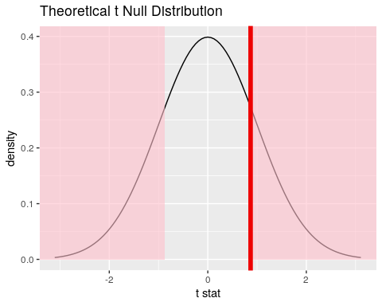
Overlay
visualize(t_null_perm, method = "both") +
shade_p_value(obs_stat = obs_t, direction = "two_sided")
## Warning: Check to make sure the conditions have been met for the
## theoretical method. {infer} currently does not check these for you.
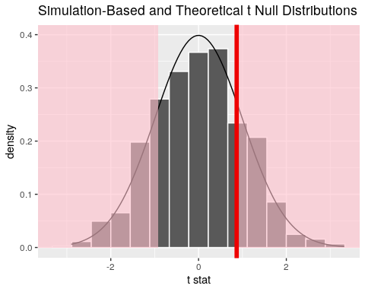
Compute the Theoretical p-value
fli_small %>%
t_test(formula = arr_delay ~ half_year,
alternative = "two_sided",
order = c("h1", "h2")) %>%
dplyr::pull(p_value)
## [1] 0.3855325

