Factors
Here are some examples from Chapter 15. The examples are related to the General Social Survey from NORC at the Unversity of Chicago.
library(tidyverse)
library(forcats)
gss_cat
## # A tibble: 21,483 x 9
## year marital age race rincome partyid relig denom tvhours
## <int> <fct> <int> <fct> <fct> <fct> <fct> <fct> <int>
## 1 2000 Never ma… 26 White $8000 to… Ind,near … Protes… Southe… 12
## 2 2000 Divorced 48 White $8000 to… Not str r… Protes… Baptis… NA
## 3 2000 Widowed 67 White Not appl… Independe… Protes… No den… 2
## 4 2000 Never ma… 39 White Not appl… Ind,near … Orthod… Not ap… 4
## 5 2000 Divorced 25 White Not appl… Not str d… None Not ap… 1
## 6 2000 Married 25 White $20000 -… Strong de… Protes… Southe… NA
## 7 2000 Never ma… 36 White $25000 o… Not str r… Christ… Not ap… 3
## 8 2000 Divorced 44 White $7000 to… Ind,near … Protes… Luther… NA
## 9 2000 Married 44 White $25000 o… Not str d… Protes… Other 0
## 10 2000 Married 47 White $25000 o… Strong re… Protes… Southe… 3
## # … with 21,473 more rows
gss_cat %>%
count(race)
## # A tibble: 3 x 2
## race n
## <fct> <int>
## 1 Other 1959
## 2 Black 3129
## 3 White 16395
Factor variables are used to make bar charts. The geom_bar() counts the observations in each level of the factor.
ggplot(gss_cat, aes(race)) +
geom_bar()
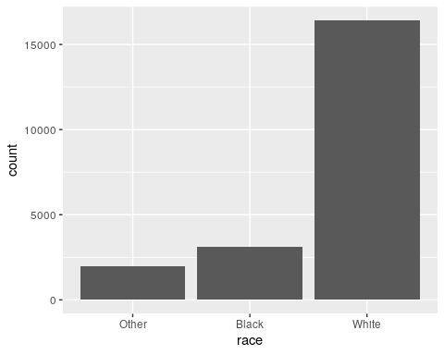
Forcing NAs.
ggplot(gss_cat, aes(race)) +
geom_bar() +
scale_x_discrete(drop = FALSE)
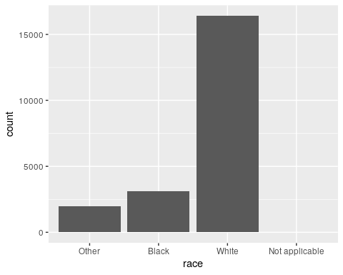
Modifying the order of a factor.
Examine tv watch time by religion.
relig_summary <- gss_cat %>%
group_by(relig) %>%
summarise(
age = mean(age, na.rm = TRUE),
tvhours = mean(tvhours, na.rm = TRUE),
n = n()
)
relig_summary %>% ggplot(aes(tvhours, relig)) + geom_point()
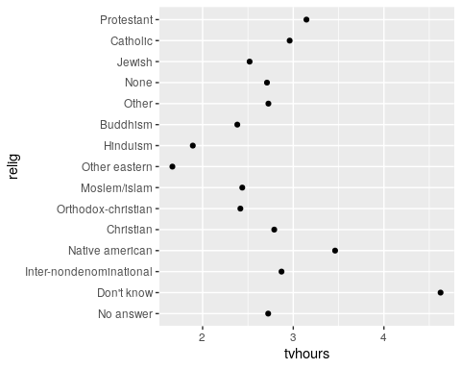
relig_summary %>% ggplot(aes(tvhours, fct_reorder(relig, tvhours))) +
geom_point()
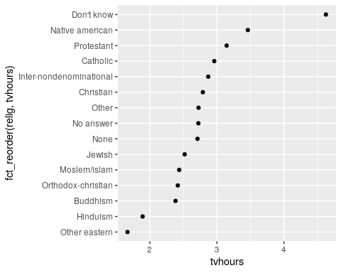
The fct_reorder() functon should be used in a mutate statement.
Same as the last code.
relig_summary %>%
mutate(relig = fct_reorder(relig, tvhours)) %>%
ggplot(aes(tvhours, relig)) +
geom_point()
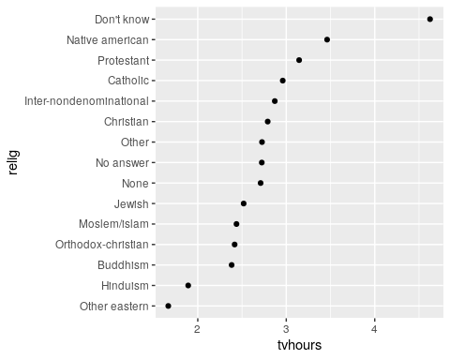
Now tv watch time by average age.
rincome_summary <- gss_cat %>%
group_by(rincome) %>%
summarise(
age = mean(age, na.rm = TRUE),
tvhours = mean(tvhours, na.rm = TRUE),
n = n()
)
rincome_summary %>% ggplot(aes(age, fct_reorder(rincome, age))) +
geom_point()
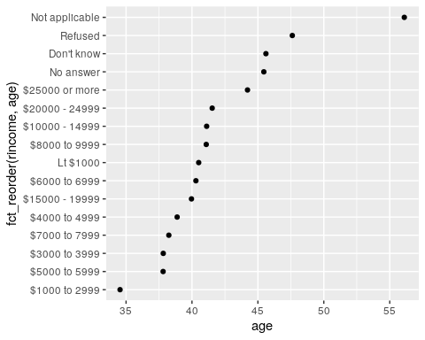
Does this make sense? What is wrong with this plot?
rincome_summary %>%ggplot(aes(age, fct_relevel(rincome, "Not applicable"))) +
geom_point()
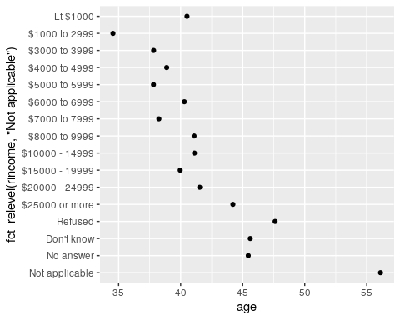
Using mutate()
gss_cat %>% ggplot(aes(marital)) +
geom_bar()
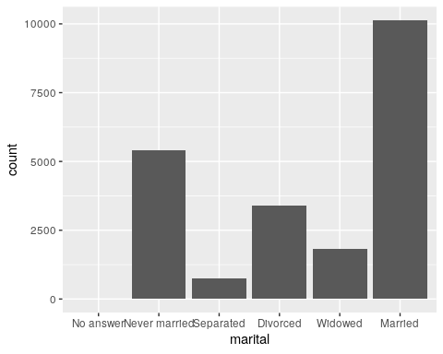
gss_cat %>% mutate(marital = marital) %>%
ggplot(aes(marital)) +
geom_bar()
gss_cat %>% mutate(marital = marital %>% fct_infreq()) %>%
ggplot(aes(marital)) +
geom_bar()
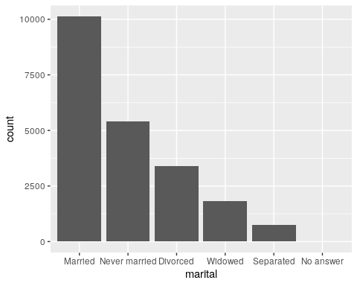
gss_cat %>% mutate(marital = marital %>% fct_infreq() %>% fct_rev()) %>%
ggplot(aes(marital)) +
geom_bar()
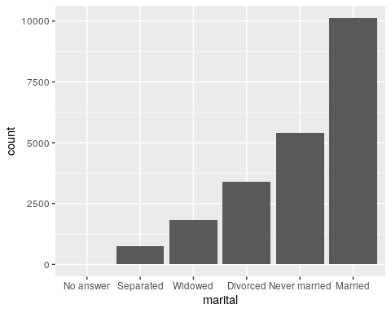
Modifying factor levels.
gss_cat %>% count(partyid)
## # A tibble: 10 x 2
## partyid n
## <fct> <int>
## 1 No answer 154
## 2 Don't know 1
## 3 Other party 393
## 4 Strong republican 2314
## 5 Not str republican 3032
## 6 Ind,near rep 1791
## 7 Independent 4119
## 8 Ind,near dem 2499
## 9 Not str democrat 3690
## 10 Strong democrat 3490
Re-coding
gss_cat %>%
mutate(partyid = fct_recode(partyid,
"Republican, strong" = "Strong republican",
"Republican, weak" = "Not str republican",
"Independent, near rep" = "Ind,near rep",
"Independent, near dem" = "Ind,near dem",
"Democrat, weak" = "Not str democrat",
"Democrat, strong" = "Strong democrat"
)) %>%
count(partyid)
## # A tibble: 10 x 2
## partyid n
## <fct> <int>
## 1 No answer 154
## 2 Don't know 1
## 3 Other party 393
## 4 Republican, strong 2314
## 5 Republican, weak 3032
## 6 Independent, near rep 1791
## 7 Independent 4119
## 8 Independent, near dem 2499
## 9 Democrat, weak 3690
## 10 Democrat, strong 3490
Other category
gss_cat %>%
mutate(partyid = fct_recode(partyid,
"Republican, strong" = "Strong republican",
"Republican, weak" = "Not str republican",
"Independent, near rep" = "Ind,near rep",
"Independent, near dem" = "Ind,near dem",
"Democrat, weak" = "Not str democrat",
"Democrat, strong" = "Strong democrat",
"Other" = "No answer",
"Other" = "Don't know",
"Other" = "Other party"
)) %>%
count(partyid)
## # A tibble: 8 x 2
## partyid n
## <fct> <int>
## 1 Other 548
## 2 Republican, strong 2314
## 3 Republican, weak 3032
## 4 Independent, near rep 1791
## 5 Independent 4119
## 6 Independent, near dem 2499
## 7 Democrat, weak 3690
## 8 Democrat, strong 3490
Collapse a factor
gss_cat %>%
mutate(partyid = fct_collapse(partyid,
other = c("No answer", "Don't know", "Other party"),
rep = c("Strong republican", "Not str republican"),
ind = c("Ind,near rep", "Independent", "Ind,near dem"),
dem = c("Not str democrat", "Strong democrat")
)) %>%
count(partyid)
## # A tibble: 4 x 2
## partyid n
## <fct> <int>
## 1 other 548
## 2 rep 5346
## 3 ind 8409
## 4 dem 7180

