ExploratoryDataAnalysis2
Table of Contents

Comparing Two Variables.
Today we will continue to discuss Exploratory Data Analysis (EDA).
- Two categorical variables.
- One categorical variable and one numeric variable.
- Two numeric variables.
library(tidyverse)

Two categorical variables.
diamonds %>% ggplot(aes(x = cut, y = color)) +
geom_count()
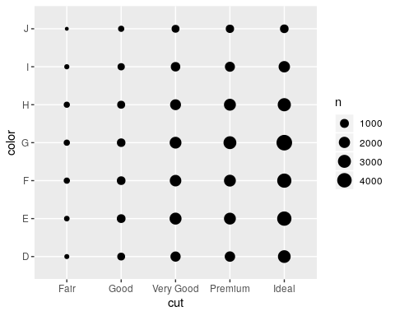
diamonds %>%
count(color, cut) %>%
ggplot(mapping = aes(x = cut, y = color)) +
geom_tile(mapping = aes(fill = n))
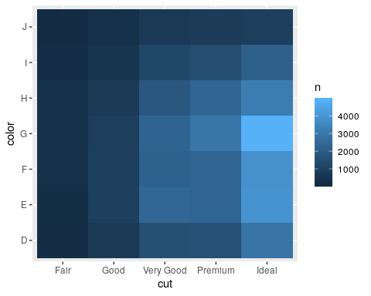
diamonds %>% count(color, cut)
## # A tibble: 35 x 3
## color cut n
## <ord> <ord> <int>
## 1 D Fair 163
## 2 D Good 662
## 3 D Very Good 1513
## 4 D Premium 1603
## 5 D Ideal 2834
## 6 E Fair 224
## 7 E Good 933
## 8 E Very Good 2400
## 9 E Premium 2337
## 10 E Ideal 3903
## # … with 25 more rows
diamonds %>% group_by(color, cut) %>%
summarise(n=n())
## # A tibble: 35 x 3
## # Groups: color [7]
## color cut n
## <ord> <ord> <int>
## 1 D Fair 163
## 2 D Good 662
## 3 D Very Good 1513
## 4 D Premium 1603
## 5 D Ideal 2834
## 6 E Fair 224
## 7 E Good 933
## 8 E Very Good 2400
## 9 E Premium 2337
## 10 E Ideal 3903
## # … with 25 more rows

Contingency table.
diamonds %>% group_by(color, cut) %>%
summarise(n=n()) %>%
spread(cut, n)
## # A tibble: 7 x 6
## # Groups: color [7]
## color Fair Good `Very Good` Premium Ideal
## <ord> <int> <int> <int> <int> <int>
## 1 D 163 662 1513 1603 2834
## 2 E 224 933 2400 2337 3903
## 3 F 312 909 2164 2331 3826
## 4 G 314 871 2299 2924 4884
## 5 H 303 702 1824 2360 3115
## 6 I 175 522 1204 1428 2093
## 7 J 119 307 678 808 896
Using the new pivot_wider() function, that replaces the spread(). You will need to update the tidyr package to version 1.0. The new function has a name that makes more sense and is more memorable.
diamonds %>% group_by(color, cut) %>%
summarise(n=n()) %>%
pivot_wider(
names_from = cut,
values_from = n
)
## # A tibble: 7 x 6
## # Groups: color [7]
## color Fair Good `Very Good` Premium Ideal
## <ord> <int> <int> <int> <int> <int>
## 1 D 163 662 1513 1603 2834
## 2 E 224 933 2400 2337 3903
## 3 F 312 909 2164 2331 3826
## 4 G 314 871 2299 2924 4884
## 5 H 303 702 1824 2360 3115
## 6 I 175 522 1204 1428 2093
## 7 J 119 307 678 808 896
Export the data to an Excel file and try making this Pivot Table.
write.csv(diamonds, file="~/diamonds.csv")

One categorical variables and one numeric.
ggplot(data = diamonds, mapping = aes(x = price)) +
geom_freqpoly(mapping = aes(colour = cut), binwidth = 500)
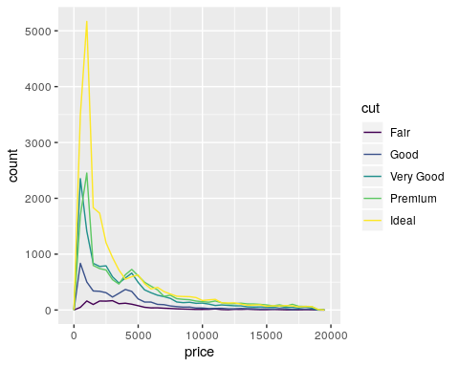
ggplot(data = diamonds, mapping = aes(x = price, y = ..density..)) +
geom_freqpoly(mapping = aes(colour = cut), binwidth = 500)
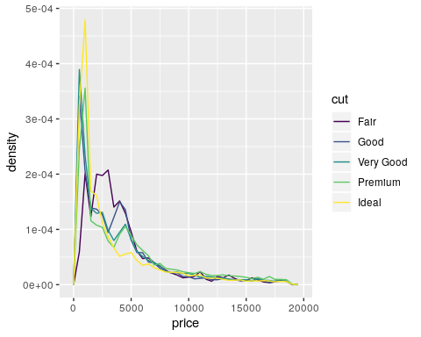
ggplot(data = diamonds, mapping = aes(x = cut, y = price)) +
geom_boxplot()
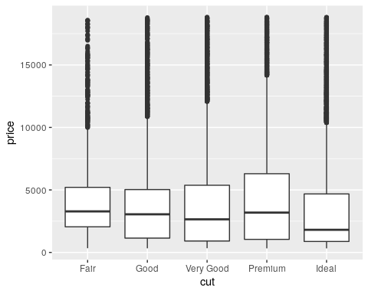

Two numeric variables.
ggplot(data = diamonds) +
geom_point(mapping = aes(x = carat, y = price))
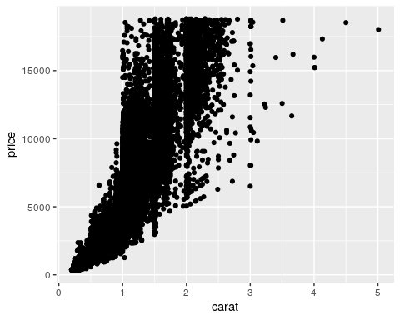
ggplot(data = diamonds) +
geom_point(mapping = aes(x = carat, y = price), alpha = 1 / 100)
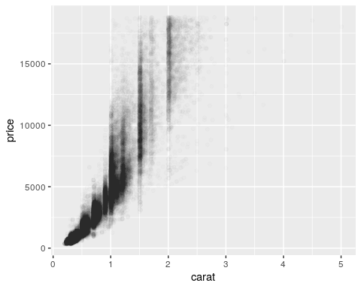
smaller <- diamonds %>%
filter(carat < 3)
ggplot(data = smaller) +
geom_bin2d(mapping = aes(x = carat, y = price))
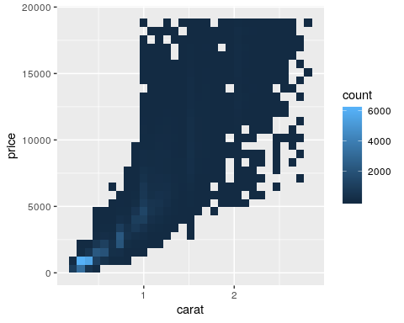
library(hexbin)
ggplot(data = smaller) +
geom_hex(mapping = aes(x = carat, y = price))
