Explore and Visualize2
Prof. Eric A. Suess

Chapter 3 Data Visualization
- Geometric shapes
- Multiple smoothing lines
- Statistical transformations
Today we are going to try some more code from Chapter 3 Data Visualization.
To start we will load the tidyverse. Note that ggplot2 is the first package loaded!
library(tidyverse)
We will continue to work with the mpg dataset that is in the ggplot2 package.
mpg
## # A tibble: 234 x 11
## manufacturer model displ year cyl trans drv cty hwy fl cla…
## <chr> <chr> <dbl> <int> <int> <chr> <chr> <int> <int> <chr> <ch>
## 1 audi a4 1.8 1999 4 auto… f 18 29 p com…
## 2 audi a4 1.8 1999 4 manu… f 21 29 p com…
## 3 audi a4 2 2008 4 manu… f 20 31 p com…
## 4 audi a4 2 2008 4 auto… f 21 30 p com…
## 5 audi a4 2.8 1999 6 auto… f 16 26 p com…
## 6 audi a4 2.8 1999 6 manu… f 18 26 p com…
## 7 audi a4 3.1 2008 6 auto… f 18 27 p com…
## 8 audi a4 q… 1.8 1999 4 manu… 4 18 26 p com…
## 9 audi a4 q… 1.8 1999 4 auto… 4 16 25 p com…
## 10 audi a4 q… 2 2008 4 manu… 4 20 28 p com…
## # ... with 224 more rows
Make the scatterplot along with the smoothing line.
ggplot(data = mpg) +
geom_point(mapping = aes(x = displ, y = hwy)) +
geom_smooth(mapping = aes(x = displ, y = hwy))
## `geom_smooth()` using method = 'loess' and formula 'y ~ x'
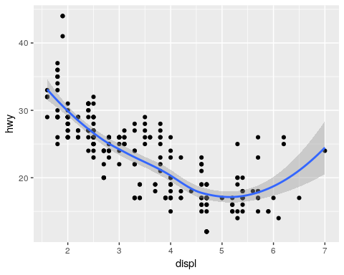
Multiple smoothing lines.
ggplot(data = mpg) +
geom_smooth(mapping = aes(x = displ, y = hwy, linetype = drv))
## `geom_smooth()` using method = 'loess' and formula 'y ~ x'
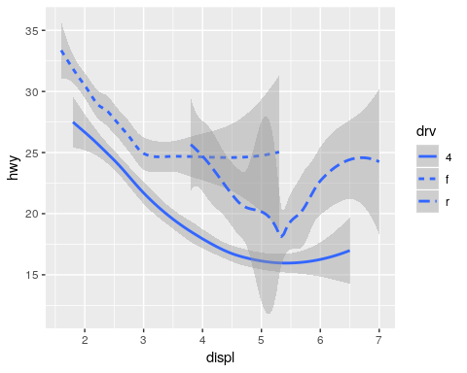
Statistical transformations
ggplot(data = diamonds) +
geom_bar(mapping = aes(x = cut))
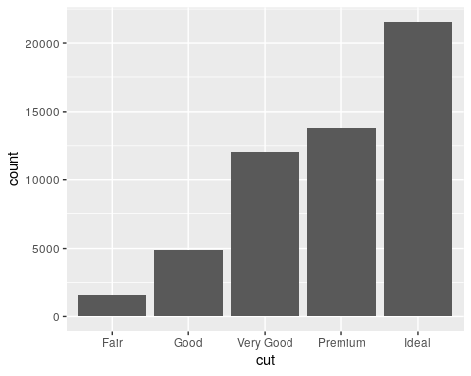
Proportions
ggplot(data = diamonds) +
geom_bar(mapping = aes(x = cut, y = ..prop.., group = 1))
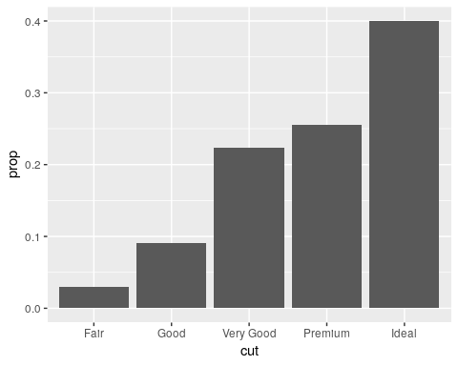
Position adjustment
ggplot(data = diamonds) +
geom_bar(mapping = aes(x = cut, fill = clarity), position = "dodge")
