Explore and Visualize
Prof. Eric A. Suess

Chapter 3 Data Visualization
- ggplot2
- scatterplots, points, color, shape
- faceting
Today we are going to try some of the code from Chapter 3 Data Visualization.
To start we will load the tidyverse. Note that ggplot2 is the first package loaded!
library(tidyverse)
We will start the mpg dataset that is in the ggplot2 package.
mpg
## # A tibble: 234 x 11
## manufacturer model displ year cyl trans drv cty hwy fl cla…
## <chr> <chr> <dbl> <int> <int> <chr> <chr> <int> <int> <chr> <ch>
## 1 audi a4 1.8 1999 4 auto… f 18 29 p com…
## 2 audi a4 1.8 1999 4 manu… f 21 29 p com…
## 3 audi a4 2 2008 4 manu… f 20 31 p com…
## 4 audi a4 2 2008 4 auto… f 21 30 p com…
## 5 audi a4 2.8 1999 6 auto… f 16 26 p com…
## 6 audi a4 2.8 1999 6 manu… f 18 26 p com…
## 7 audi a4 3.1 2008 6 auto… f 18 27 p com…
## 8 audi a4 q… 1.8 1999 4 manu… 4 18 26 p com…
## 9 audi a4 q… 1.8 1999 4 auto… 4 16 25 p com…
## 10 audi a4 q… 2 2008 4 manu… 4 20 28 p com…
## # ... with 224 more rows
Make a scatterplot of highway miles per gallon (hwy) and engine size (displ).
Start with an empty graph and add to it.
ggplot(data = mpg)
Add points using geom_point mapping and aesthetic.
ggplot(data = mpg) +
geom_point(mapping = aes(x = displ, y = hwy))
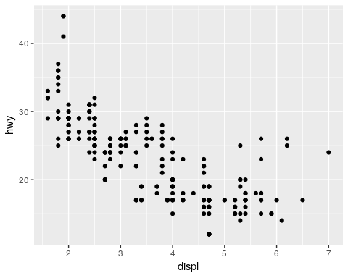
Add color.
ggplot(data = mpg) +
geom_point(mapping = aes(x = displ, y = hwy, color = class))
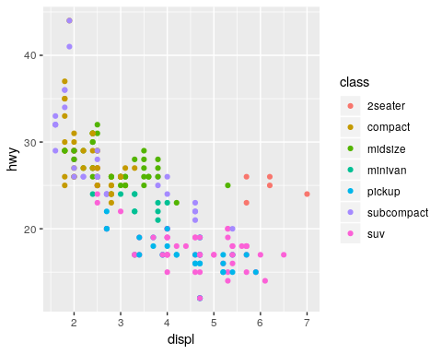
Change size of the points.
ggplot(data = mpg) +
geom_point(mapping = aes(x = displ, y = hwy, size = class))
## Warning: Using size for a discrete variable is not advised.
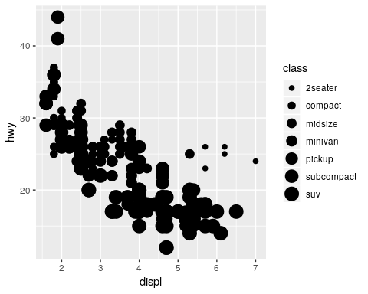
Change the transparentcy or shape.
# Left
ggplot(data = mpg) +
geom_point(mapping = aes(x = displ, y = hwy, alpha = class))
## Warning: Using alpha for a discrete variable is not advised.
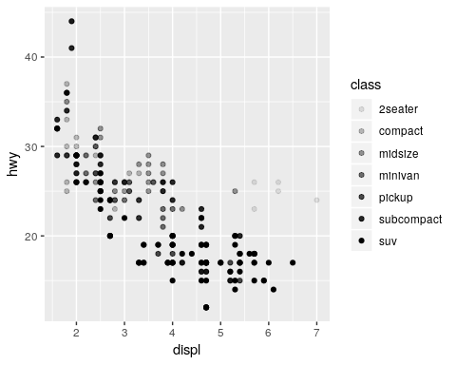
# Right
ggplot(data = mpg) +
geom_point(mapping = aes(x = displ, y = hwy, shape = class))
## Warning: The shape palette can deal with a maximum of 6 discrete values
## because more than 6 becomes difficult to discriminate; you have 7.
## Consider specifying shapes manually if you must have them.
## Warning: Removed 62 rows containing missing values (geom_point).
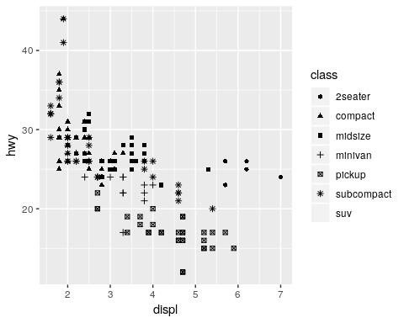
Specify color.
ggplot(data = mpg) +
geom_point(mapping = aes(x = displ, y = hwy), color = "blue")
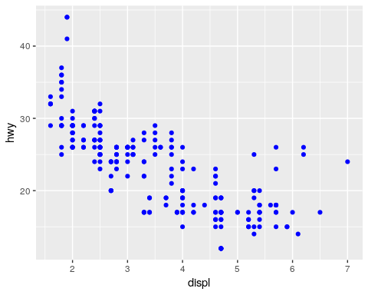
Faceting, spliting a plot into separate plots for different levels of a categorical variable.
ggplot(data = mpg) +
geom_point(mapping = aes(x = displ, y = hwy)) +
facet_wrap(~ class, nrow = 2)
