Stat. 450 Section 1 or 2: Homework 5
Prof. Eric A. Suess
So how should you complete your homework for this class?
- First thing to do is type all of your information about the problems you do in the text part of your R Notebook.
- Second thing to do is type all of your R code into R chunks that can be run.
- If you load the tidyverse in an R Notebook chunk, be sure to include the “message = FALSE” in the {r}, so {r message = FALSE}.
- Last thing is to spell check your R Notebook. Edit > Check Spelling… or hit the F7 key.
Homework 5:
Read: Chapter 7
Do 7.3.4 Exercises 1, 2, 3, 4
Do 7.4.1 Exercises 1, 2
Do 7.5.1.1 Exercises 2, 3, 4, 5, 6
library(tidyverse)

7.3.4

1.
All are skewed to the right. The distributions of x and y are very similar. The distributions of z looks to be less spread out. All look to be bimodal.
I think x and y are the length and width, and z is the depth.
diamonds
## # A tibble: 53,940 x 10
## carat cut color clarity depth table price x y z
## <dbl> <ord> <ord> <ord> <dbl> <dbl> <int> <dbl> <dbl> <dbl>
## 1 0.23 Ideal E SI2 61.5 55 326 3.95 3.98 2.43
## 2 0.21 Premium E SI1 59.8 61 326 3.89 3.84 2.31
## 3 0.23 Good E VS1 56.9 65 327 4.05 4.07 2.31
## 4 0.290 Premium I VS2 62.4 58 334 4.2 4.23 2.63
## 5 0.31 Good J SI2 63.3 58 335 4.34 4.35 2.75
## 6 0.24 Very Good J VVS2 62.8 57 336 3.94 3.96 2.48
## 7 0.24 Very Good I VVS1 62.3 57 336 3.95 3.98 2.47
## 8 0.26 Very Good H SI1 61.9 55 337 4.07 4.11 2.53
## 9 0.22 Fair E VS2 65.1 61 337 3.87 3.78 2.49
## 10 0.23 Very Good H VS1 59.4 61 338 4 4.05 2.39
## # ... with 53,930 more rows
diamonds %>% select(x,y,z) %>%
ggplot(aes(x = x )) +
geom_histogram() +
scale_x_continuous(limits=c(0, 10)) +
scale_y_continuous(limits=c(0, 15000))
## `stat_bin()` using `bins = 30`. Pick better value with `binwidth`.
## Warning: Removed 5 rows containing non-finite values (stat_bin).
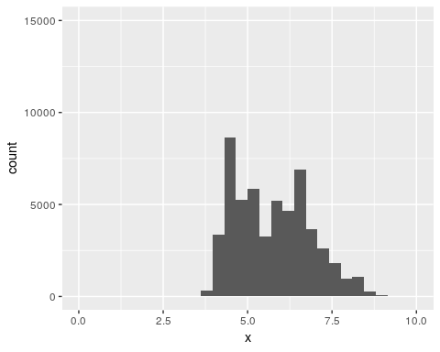
diamonds %>% select(x,y,z) %>%
ggplot(aes(x = y )) +
geom_histogram() +
scale_x_continuous(limits=c(0, 10)) +
scale_y_continuous(limits=c(0, 15000))
## `stat_bin()` using `bins = 30`. Pick better value with `binwidth`.
## Warning: Removed 5 rows containing non-finite values (stat_bin).
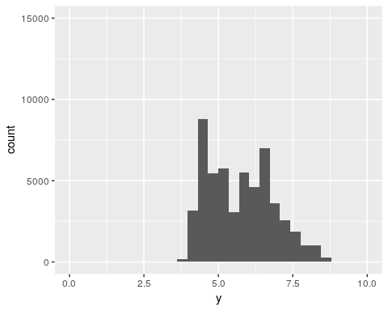
diamonds %>% select(x,y,z) %>%
ggplot(aes(x = z )) +
geom_histogram() +
scale_x_continuous(limits=c(0, 10)) +
scale_y_continuous(limits=c(0, 15000))
## `stat_bin()` using `bins = 30`. Pick better value with `binwidth`.
## Warning: Removed 1 rows containing non-finite values (stat_bin).
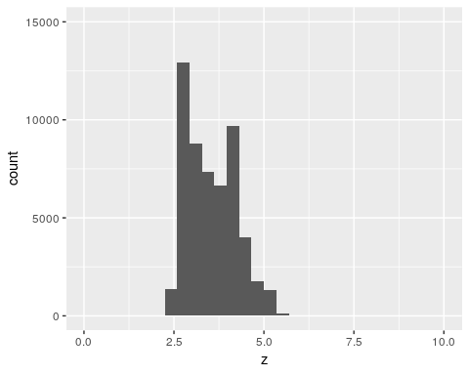

2.
There are not prices around $1500.
The mode of the distributions is around $750.
At the lowest levels there are spikes in the prices where the diamonds are actually priced.
diamonds %>% select(price) %>%
ggplot(aes(x = price )) +
geom_histogram()
## `stat_bin()` using `bins = 30`. Pick better value with `binwidth`.
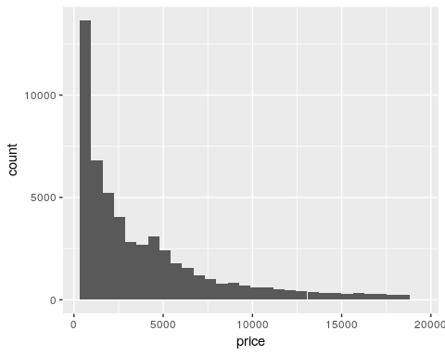
diamonds %>% select( price ) %>%
filter(price < 2500) %>%
ggplot(aes(x = price )) +
geom_histogram()
## `stat_bin()` using `bins = 30`. Pick better value with `binwidth`.
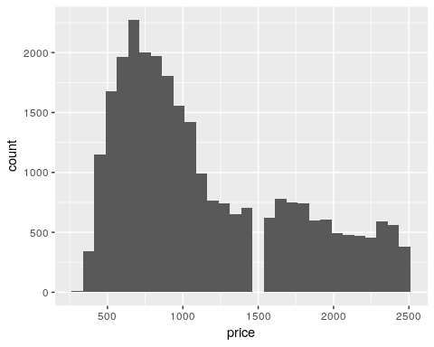
diamonds %>% select( price ) %>%
filter(price < 2500) %>%
ggplot(aes(x = price )) +
geom_histogram(binwidth = 10, center = 0 )
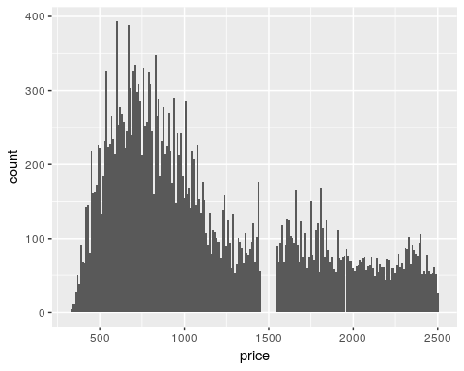
diamonds %>% select( price ) %>%
filter(price < 900, price > 800) %>%
ggplot(aes(x = price )) +
geom_histogram(binwidth = 01, center = 0 )
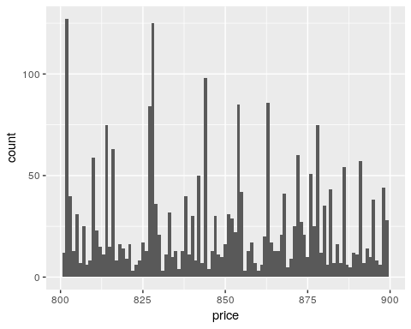

3.
There are 23 diamonds that are .99 carats and there are 1558 diamonds that are 1 carat. Rounding up is worth more money.
diamonds %>% select(carat) %>%
count(carat == 0.99)
## # A tibble: 2 x 2
## `carat == 0.99` n
## <lgl> <int>
## 1 FALSE 53917
## 2 TRUE 23
diamonds %>% select(carat) %>%
count(carat == 1)
## # A tibble: 2 x 2
## `carat == 1` n
## <lgl> <int>
## 1 FALSE 52382
## 2 TRUE 1558
diamonds %>%
filter(carat >= 0.9, carat <= 1.1) %>%
count(carat)
## # A tibble: 21 x 2
## carat n
## <dbl> <int>
## 1 0.9 1485
## 2 0.91 570
## 3 0.92 226
## 4 0.93 142
## 5 0.94 59
## 6 0.95 65
## 7 0.96 103
## 8 0.97 59
## 9 0.98 31
## 10 0.99 23
## # ... with 11 more rows
diamonds %>%
filter(carat >= 0.9, carat <= 1.1) %>%
count(carat) %>%
ggplot(aes(x= carat, y = n)) +
geom_col()
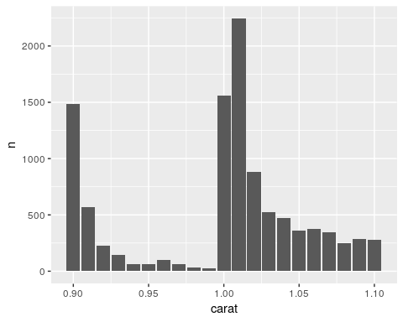

4.
The cood_cartesian function zooms in on the original histogram.
The xlim and ylim functions limits the range of the data before counting. So the histogram is made for a subset of the data.
diamonds %>% select(price) %>%
ggplot(aes(x = price )) +
geom_histogram()
## `stat_bin()` using `bins = 30`. Pick better value with `binwidth`.
diamonds %>% select(price) %>%
ggplot(aes(x = price )) +
geom_histogram() +
coord_cartesian(xlim = c(0, 5000), ylim = c(0, 10000))
## `stat_bin()` using `bins = 30`. Pick better value with `binwidth`.
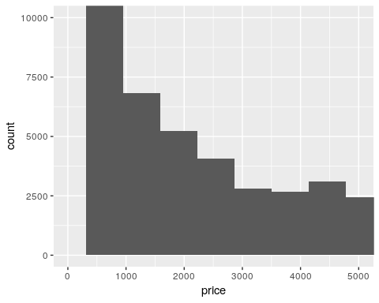
diamonds %>% select(price) %>%
ggplot(aes(x = price )) +
geom_histogram(binwidth = 100) +
coord_cartesian(xlim = c(0, 5000), ylim = c(0, 10000))
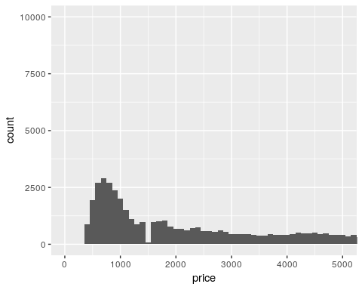
diamonds %>% select(price) %>%
ggplot(aes(x = price )) +
geom_histogram(binwidth = 100) +
xlim(0, 5000) +
ylim(0, 10000)
## Warning: Removed 14714 rows containing non-finite values (stat_bin).
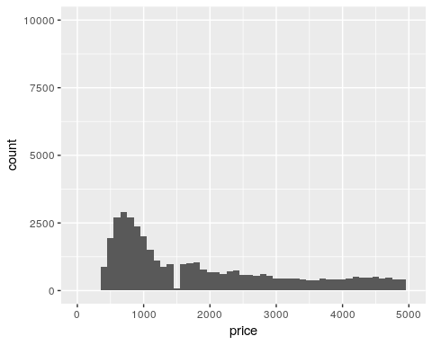

7.4.1

1.
For histograms missing data is removed.
For bargraphs the NAs are considered another category.

2.
The option na.rm in the mean and sum functions remove the NAs before the values of the functions are computed. NAs are not numeric values so they cannot be included in a sum calculation.

7.5.1.1

1.
The cancelled flights tend to occur later in the day, but have a wider range of scheduled departure hour.
library(nycflights13)
flights %>% mutate(
cancelled = is.na(dep_time),
sched_hour = sched_dep_time %/% 100,
sched_min = sched_dep_time %% 100
) %>%
ggplot(aes(x = cancelled, y = sched_hour)) +
geom_boxplot() +
coord_flip()
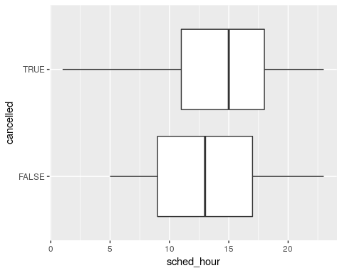

2.
The most important variable is carat.
diamonds %>% select (price, carat, depth, table, x, y , z) %>%
cor()
## price carat depth table x y
## price 1.0000000 0.92159130 -0.01064740 0.1271339 0.88443516 0.86542090
## carat 0.9215913 1.00000000 0.02822431 0.1816175 0.97509423 0.95172220
## depth -0.0106474 0.02822431 1.00000000 -0.2957785 -0.02528925 -0.02934067
## table 0.1271339 0.18161755 -0.29577852 1.0000000 0.19534428 0.18376015
## x 0.8844352 0.97509423 -0.02528925 0.1953443 1.00000000 0.97470148
## y 0.8654209 0.95172220 -0.02934067 0.1837601 0.97470148 1.00000000
## z 0.8612494 0.95338738 0.09492388 0.1509287 0.97077180 0.95200572
## z
## price 0.86124944
## carat 0.95338738
## depth 0.09492388
## table 0.15092869
## x 0.97077180
## y 0.95200572
## z 1.00000000
diamonds %>% select (price, carat, depth, table, x, y , z) %>%
ggplot(aes(x = carat, y = price)) +
geom_point()
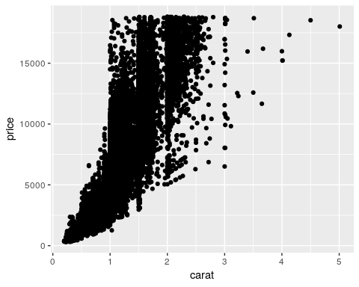
diamonds %>% ggplot(aes(x = carat, y = price)) +
geom_boxplot(aes(group = cut_width(carat, 0.1)))
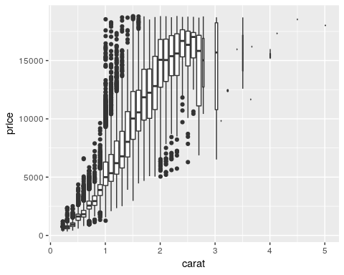
Examining the caregorical variables.
Weak positive relationship of price with color.
Weak neagative relationship of price with clarity and cut.
diamonds %>% ggplot( aes(x = color, y = price)) +
geom_boxplot()
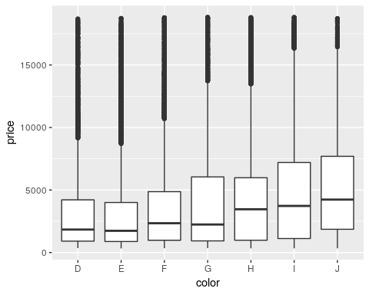
diamonds %>% ggplot(aes(x = clarity, y = price)) +
geom_boxplot()
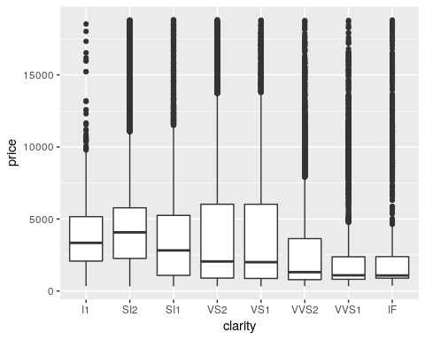
ggplot(diamonds, aes(x = cut, y = carat)) +
geom_boxplot()
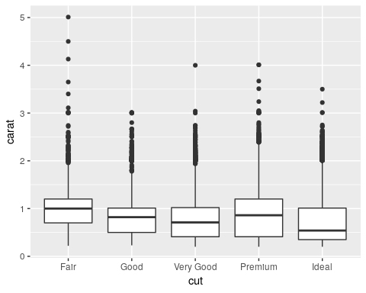

3.
Looks the same, but x and y need to be switched for the boxploth()
flights %>% mutate(
cancelled = is.na(dep_time),
sched_hour = sched_dep_time %/% 100,
sched_min = sched_dep_time %% 100
) %>%
ggplot(aes(x = cancelled, y = sched_hour)) +
geom_boxplot() +
coord_flip()
library(ggstance)
##
## Attaching package: 'ggstance'
## The following objects are masked from 'package:ggplot2':
##
## geom_errorbarh, GeomErrorbarh
flights %>% mutate(
cancelled = is.na(dep_time),
sched_hour = sched_dep_time %/% 100,
sched_min = sched_dep_time %% 100
) %>%
ggplot(aes(y = cancelled, x = sched_hour)) +
geom_boxploth()

4.
The boxes in the lvplot correspond to percentiles, every 10%.
Outliers are in the direction of the thinner percentiles.
library(lvplot)
diamonds %>% select(price, cut) %>%
ggplot(aes(x = cut, y = price)) +
geom_lv() +
coord_flip()
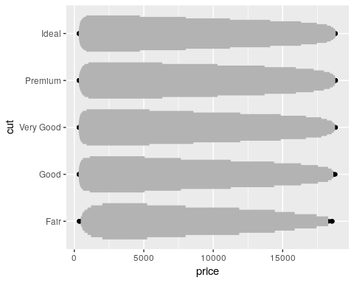
flights %>% mutate(
cancelled = is.na(dep_time),
sched_hour = sched_dep_time %/% 100,
sched_min = sched_dep_time %% 100
) %>%
ggplot(aes(x = cancelled, y = sched_hour)) +
geom_lv() +
coord_flip()
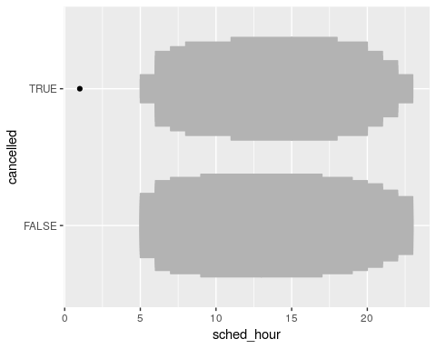

5.
The facted histograms are printed in the reverse order of the violin plots. I would be good to have the vertical scales the same.
flights %>% mutate(
cancelled = is.na(dep_time),
sched_hour = sched_dep_time %/% 100,
sched_min = sched_dep_time %% 100
) %>%
ggplot(aes(x = cancelled, y = sched_hour)) +
geom_violin() +
coord_flip()
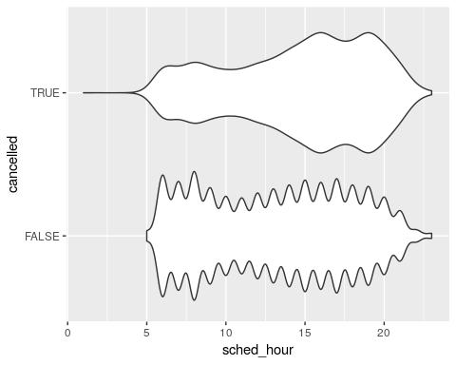
flights %>% mutate(
cancelled = is.na(dep_time),
sched_hour = sched_dep_time %/% 100,
sched_min = sched_dep_time %% 100
) %>%
ggplot(aes( x = sched_hour )) +
geom_histogram() +
facet_wrap(~ cancelled, nrow = 2)
## `stat_bin()` using `bins = 30`. Pick better value with `binwidth`.
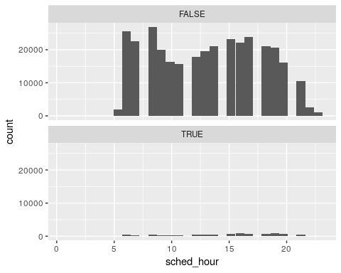

6.
method | description
default | jitters the point horizontally
tukey | jitters more
tukeyDense | jitters but less than tukey
frowney | jitters downward
smiley | jitters upward
library(ggbeeswarm)
mpg %>% ggplot(aes(x = reorder(class, hwy, FUN = median),y = hwy) ) +
geom_beeswarm()
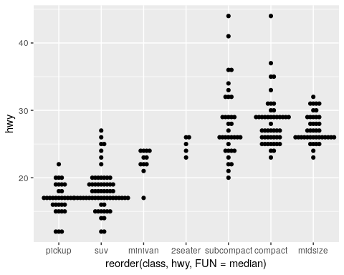
mpg %>% ggplot(aes(x = reorder(class, hwy, FUN = median),y = hwy) ) +
geom_quasirandom()
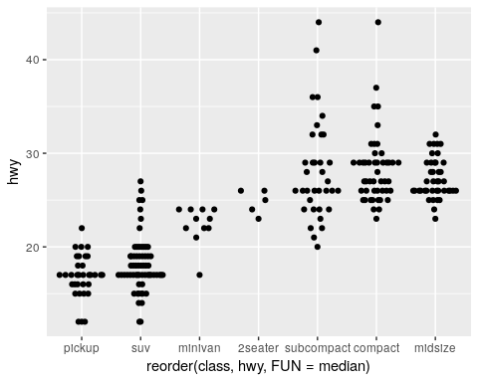
mpg %>% ggplot(aes(x = reorder(class, hwy, FUN = median),y = hwy) ) +
geom_quasirandom(method = "tukey")
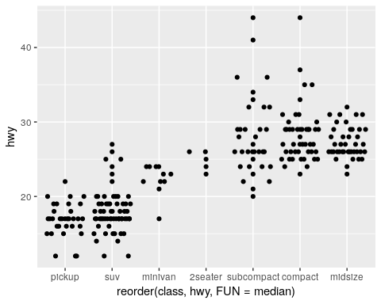
mpg %>% ggplot(aes(x = reorder(class, hwy, FUN = median),y = hwy) ) +
geom_quasirandom(method = "tukeyDense")
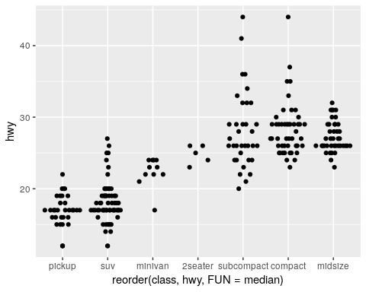
mpg %>% ggplot(aes(x = reorder(class, hwy, FUN = median),y = hwy) ) +
geom_quasirandom(method = "frowney")
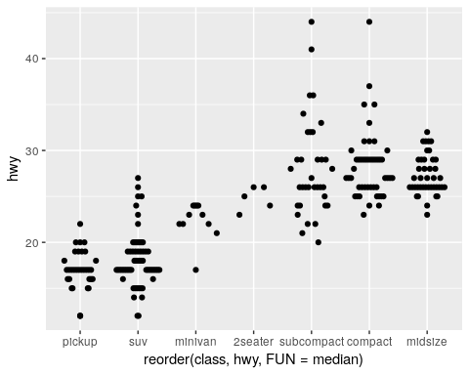
mpg %>% ggplot(aes(x = reorder(class, hwy, FUN = median),y = hwy) ) +
geom_quasirandom(method = "smiley")
